**MONITORING ACTIVITIES OF ELDERLY PEOPLE USING WEARABLE SENSORS AND SECURE COMMUNICATION TO THE REMOTE LOCATION**

**J COMPONENT PROJECT REPORT**

**SLOT A1**

*Submitted by*

**Swayam Prakash Pati 19BCT0161** [**swayamprakash.pati2019@vitstudent.ac.in**](mailto:swayamprakash.pati2019@vitstudent.ac.in)

**Rachit Elhance 19BCT0187** [**rachit.elhance2019@vitstudent.ac.in**](mailto:rachit.elhance2019@vitstudent.ac.in)



**Rahul Chetan Thakar 19BCT0192** [**rahul.thakar2019@vitstudent.ac.in**](mailto:rahul.thakar2019@vitstudent.ac.in)



**Disha Jain 19BCT0219** [**disha.jain2019@vitstudent.ac.in**](mailto:disha.jain2019@vitstudent.ac.in)

Course Code: BCT3001

Course Title: Wireless Ad Hoc and Sensor Networks

Under the Guidance of

**S.Ananda Kumar**

**B.Tech**

**In**

**Computer Science and Engineering Specialization in IoT**

**Table of Contents**

| **S.No** | **Contents** | **Page Number** |
| --- | --- | --- |
| **1** | **Abstract** | **2** |
| **2** | **Introduction** | **3** |
| **3** | **3.1 Literature Review**  **3.2 Survey Table( one or two pages )**  **3.3 Problem Definition** | **5**  **40**  **42** |
| **4** | **4.1 Proposed Method**  **4.2 Flow Diagram**  **4.3 Proposed Algorithm**  **4.4 Components Used**  **4.5 Circuit Diagram** | **42**  **48**  **49**  **50**  **52** |
| **5** | **Implementation** | **54** |
| **6** | **Results and Discussions** | **58** |
| **7** | **Conclusion** | **65** |
| **8** | **Future Work** | **65** |
| **9** | **References** | **66** |
| **10** | **Supporting Documents**  **9.1 Complete Code**  **9.2 Generated csv file**  **9.3 Video Link:** | **69** |

**Monitoring Activities of Elderly People Using Wearable Sensors and Secure Communication to the Remote Location**

Swayam Prakash Pati (19BCT0161) Rachit Elhance (19BCT0187)

([swayamprakash.pati2019@vitstudent.ac.in](mailto:swayamprakash.pati2019@vitstudent.ac.in)) ([rachit.elhance2019@vitstudent.ac.in](mailto:rachit.elhance2019@vitstudent.ac.in))

Rahul Chetan Thakar (19BCT0192) Disha Jain (19BCT0219)

([rahul.thakar2019@vitstudent.ac.in](mailto:rahul.thakar2019@vitstudent.ac.in)) ([disha.jain2019@vitstudent.ac.in](mailto:disha.jain2019@vitstudent.ac.in))

VIT - Vellore Institute of Technology

**1.Abstract**

According to the report by the UN Health Ministry, the global population aged 60 years or over numbered 962 million in 2017, more than twice as large as in 1980 when there were 382 million older persons worldwide. It says that the number of older people is expected to double again by 2050, when it is projected to reach nearly 2.1 billion. It has been established that even subtle changes in the behavior of the elderly can give important signs of the onset and progression of certain diseases. Abnormal patterns like disturbed sleeping patterns could be caused, for example, by degenerative joint disease, gastro-oesophageal reflux along with congestive heart failure and chronic obstructive pulmonary disease. Problems like changes in gait can be associated with early signs of neurological abnormalities linked to several types of non-Alzheimer dementias. Patients with neurologic gait abnormalities have a greater risk of developing dementia. Continuous monitoring from hospitals also causes lack of medical resources.

This paper presents a framework which utilizes Wearable Sensors for data accumulation, a Smart-phone app to act as a Gateway and Cloud based services to provide necessary database management services. In the model, the system is responsible for collecting patient’s physiological data via wearable sensors (i.e., pulse, SpO2 oxygen etc.) of elderly people in real-time. The data is transmitted to a cloud via a gateway, where it will be stored and checked for any abnormality. Thus, as soon as there is any detection of disorder in a patient's vitals, it will be reported to the patient's doctors and/or hospital to act on quickly and prevent problems like sudden heart attacks.

**Keywords :** Health Monitoring, Sensors, Gateway, Cloud, MQTT, AWS DynamoDB, AWS Iot-Core

**2.Introduction**

Monitoring and recording real-time information about one's physiological condition and motion activities are well done by Wearable Sensors. Different types of flexible sensors are composed in Wearable sensor-based health monitoring systems that can be integrated into textile clothes, fiber, and elastic bands or can be even directly attached to the human body. The sensors are capable of measuring physiological signs such as body temperature, electrodermal activity (EDA), arterial oxygen saturation (SpO2), respiration rate (RR) , electromyogram (EMG), heart rate (HR), blood pressure (BP) and electrocardiogram (ECG). Miniature motion sensors based on micro-electro-mechanical systems (MEMS) such as gyroscopes, accelerometers, and magnetic field sensors are widely used for measuring signals related to activity.

It is well known that even subtle changes in the behavior of the elderly can give important signs of the onset and progression of certain diseases. Disturbed sleeping patterns could be caused, for example, by degenerative joint disease, gastro-oesophageal reflux along with congestive heart failure and chronic obstructive pulmonary disease. Also, real-time monitoring of an individual’s motion activities could be useful in fall detection, gait pattern and posture analysis, or in sleep assessment.

Our research motivations come from the interest in enhancing the living facilities in general, and healthcare in particular and thus we are proposing a system which enables continuous monitoring for elderly people's health in real-time to prevent chronic diseases, thus preventing hospitalization that burdens the healthcare systems and costs.

The rapid growth of wearable sensors (e.g., fitness trackers, wearable biometric sensors etc.) changes the way we collect and analyze data. A large proportion of IoT technology directly builds on the motivation of monitoring our daily activities (e.g., monitoring steps and diets throughout the day). Wearable sensor technologies and IoT have great potential to improve our lifestyle, such as providing healthcare monitoring systems which are responsible for tracking and managing our health and fitness. Additional features such as real-time communication enables the data to be transmitted and analyzed by healthcare providers while providing the means to identify and act upon worrying behavior or symptoms. Raising the efficiency and overall cost effectiveness of healthcare is one of the vital goals of modern society.

The IoT network is more interactive. Moreover, within the traditional network, the contents and/or servers are generated or consumed by humans through manual requesting for a service or data acquisition, while in the IoT network the contents and/or servers are generated or activated mostly through things (i.e., sensors and embedded systems)

Wireless sensor network (WSN) is the core of smart healthcare monitoring systems, where it represents the main sources of data, thus providing symptom physiological data from the patient's body.

Although wireless sensing technology is still in the laboratory research stage, in terms of the results obtained in this field, the wireless sensing system has a great potential application in the context of artificial intelligence. As wireless technology, digital signal processing technology, and machine learning technology are continuously improved, more novel and valuable applications in many commercial areas will be created.

The main objective of our model will be to monitor physiological data collected from patient’s wearable devices, create records in the data-center, and ultimately provide access to these data by authorized health-givers and doctors anytime, anywhere. Also we aim at providing alerts in case of emergencies. The main function of this system is the ability to identify human activities from the acquired sensory data. This is achieved by applying meaning to observations.

**3.1 Literature Review**

# **Detection of Generalized Tonic Clonic Seizures and Falls in Unconstrained Environment Using Smartphone Accelerometer , 2021**

The paper ponders upon the idea of HAR(Human Activity Recognition) through wearable sensors for detection and classification of ADLs, GTCS and Falls to prevent any consequences of Fall or seizures leading to death or serious injuries.

In the paper, HAR (Human Activity Recognition) is discussed by using wearable sensors to detect ADLs, GTCS and Falls in order to prevent any consequences of Falls or seizures that may result in death.

The model is simple and works in a way that data from wearable sensors collected in an unconstrained environment, can be used for accurate classification of ADLs and abnormalities leading to neurological disorders.

In the paper the data that is used is taken from an app called “MyNeuroHealth”.

Based on their movement trends, this data from the MyNeuroHealth application is pre-processed. The results of a classification of different activities using RF, J48, LMT, NB, and SVM classifiers show that RF performs 16% better than other classifiers in detecting GTCS, and 22% better in detecting Fall.

It is also observed that there is a certain overlap between the data points of light ambulatory and stationary activity, and the detection accuracy of light ambulatory is therefore minimal using RF classifiers.

The work ahead:

The research done is so that the next paper or the followup paper will include the integration of RF in the mobile app and improvement in the detection accuracies by inclusion of more sensors such as heart rate, EEG, skin conductivity etc. in decision making process and the release of stand-alone application to facilitate patients suffering from neurological disorders.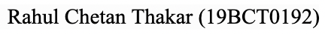

The important thing to be taken from this is that when it comes to detection of GTCS, **RF platforms** prove to be more efficient than other platforms.

# **Iot wearable sensors and devices in elderly care: A literature review, 2020**

Efficient, affordable, and accessible healthcare for elders and ailments pertinent to them are eminently needed in this day and age. IoT wearable sensors and devices have been growing immensely in the last decade, they have started to be included in our day to day lifestyle and some medical processes are heavily reliant on them.

The reviews presented in this paper have explored information in the sector of exploring, identifying, and analyzing common healthcare aspects. Healthcare aspects range from chronic disorders, mainly AD and other forms of dementia, frailty and CVD,PD, to general eldercare and AAL. All IoT technologies are notably wearables, as well as smart home sensors, microphones, camerasand indoor and outdoor tracking. The major aims include assessment of cognitive state, frailty, and other conditions, as well as support, assistance, and prevention of falls.

Common privacy frameworks and tailored security management for IoT are open issues. Aspects of this include technology hardware and software features that facilitate human needs, particularly those of elders and their ailments. There is a constant and ever-changing balance between technological capabilities as they relate to accuracy, performance, and modalities and human requirements as they relate to comfort, durability, and often esthetics. Study duration is also a key consideration.

With more advanced, durable, and comfortable technology, only made available recently, studies that explore longer-term effects and benefits could emerge. Big Data from IoT wearables could soon emerge as predictive medical tools and digital biomarkers for elderly enabling care at home, as well as pharmaceutical treatment by accelerating and optimizing clinical trials.



# **Recent Advances in Wearable Sensors with Application in Rehabilitation Motion Analysis, 2020**

Recent advances in innovative technologies such as MEMS have led to a growing interest in wearable sensors for activity monitoring.

This paper briefs on different IOT based sensors and sensor fusions that would help in the process of making Rehabilitation Motion systems.

This paper talks about sensors like:

* Electromyography Sensors
* Sock-Type Electromyography Sensors
* GNSS Receiver
* Liquid-state Conductive based Stretchable Sensors
* Conductive Hydrogel Sensor

The paper also discusses how when these sensors are paired together how they can help in the analysis. The paper described some of these fusions:

Accelerometer-Gyroscope-Magnetometer Fusion

* IMU-Force Fusion
* IMU-EMG Fusion
* Use of IMU for Fall Detection
* IMU and GNSS Receiver Coupling

The sensors most commonly used in wearable devices for activity monitoring are accelerometers, often fused with gyroscopes and magnetometers to form a common IMU. It is also true that sensor fusion can provide a more complete and accurate motion analysis. However, the focus right now should be more user friendly and easily usable devices and for that the simpler the sensors the more operable the devices will be.

The research on the uses and categorization of sensors is still lacking as there are a vast number of different sensors and fusions that could work better in making rehabilitation motion analysis devices.

# **Wireless battery-free body sensor networks using near-field-enabled clothing, 2020**

For reliable long-term monitoring Wireless and battery-free sensors are very important, but currently only near-field technologies that require close proximity (at most a few centimetres) between each sensor and a wireless readout device is relied on for achieving this mode of operation. In this paper we use near-field-enabled clothing which is capable of building wireless data and power connectivity between multiple distant points around the body creating a network of battery-free sensors. The sensors are interconnected to functional textile patterns by proximity. Embroidery of conductive threads controlled by computers are used to integrate clothing with near-field-responsive patterns. Completely fabric-based and also free of fragile silicon components are used. The paper also demonstrates the utility of the real-time networked system, spinal posture multi-node measurement and continuous sensing of temperature and gait during exercise.

They do not incorporate fragile silicon integrated circuits, the near-field-enabled clothing are entirely fabric-based. They are also robust to daily wear due to their requirement of connectors to interact with nearby devices.NFC-enabled smartphones and devices compatible Textile designs were developed without any modification. We also demonstrate their use in enabling spinal posture monitoring and continuous measurement of temperature and gait during exercise with multiple wireless, battery-free sensors.

Spinal posture monitoring with Multi-Node:

Continuous sensing of spinal posture was demonstrated by interconnecting multiple battery-free strain sensors which were distributed along the lumba, thoracic and cervical sections of the spine with a near-field-enabled clothing.

Exercise monitoring continuously:

The challenge was overcome by interconnecting NFC-based temperature and strain sensors to a smartphone reader during untethered running using near-field-enabled clothing. The monitoring system enables measurement of axillary temperature in real-time. This is an important marker of health and performance. Also running gait, an indicator for exhaustion and certain neurodegenerative diseases. Under the armpit a temperature sensor node was used, on the knee a strain sensor node, respectively.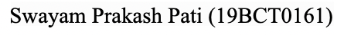

# **Wireless charging of smartwear for health and safety monitoring system, 2020**

The paper introduces a wireless charging system for a health monitoring smart-wear application of workers by considering the power consumption requirements by sensory hardware, communication technology and practical charging scenarios. Demonstration of a working prototype of a 5-Watt wireless charging device used by our health monitoring wearable is also provided. The smart wearable system collects biometric measurements and transmits data to the cloud for analysis to monitor the health and safety of workers. A feedback system enables alert signals to be sent to notify the workers when they are at risk. At the end of a shift, workers will dump the smart bands to a ‘wireless charging bin’ so that the smart bands are fully charged by their next shift.

A wristband consists of an accelerometer used to measure the movement and posture of the worker, a temperature sensor used to monitor the body temperature of the worker and the blood pressure and heart rate sensor to monitor the variability of heart rate and blood pressure when the worker is performing physical tasks. These raw biometric measurements will then be treated as inputs to the health metric algorithms to indicate the level of fatigue and dehydration, as well as the risk of osteoarthritis of workers. Narrowband IoT (NB-IoT) is used as the communication technology for the wearable modules. The knee module is responsible for collecting the biometric measurement data from the wristband using Bluetooth connection and package the data and transmit to the cloud using an embedded NB-IoT module.

Our proposed magnetic resonance-based wireless charging system can increase the charging distance from millimetres (mm) (magnetic induction) to cm. The proposed charging application aims to simultaneously charge multiple wearable devices in a confined area such as a basket. A new wireless charging system supports an application with new innovations that include a) a new micro magnetic resonance coil for higher charging efficiency, b) a one-to-many wireless charging bowl disc for multi-charge applications, c) a priority-based wireless charging method, and d) a new frequency scan and selection method for multi-charge applications.

Advantages - The module used for communication and wireless charging is selected carefully to avoid range limitation.

Disadvantages -Charging a large number of devices in a confined place may cause difficulties.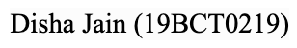

# **Monitoring Activities of Daily Living Using UWB Radar Technology: A Contactless Approach, 2020**

In this paper, the target demographic of participants were older adults. However, since the classification of ADLs only based on relative position in the prototype system, the age of participants was not relevant for completion of the experiment. No special skill was required to participate because the performed scenarios are normal ADLs. An email invitation was sent to Kristiania University College students for our convenience in finding participants. Participation is completely voluntary as mentioned in the email and one can opt out anywhere in the middle of the experiment. Encouragement was provided to experience the state-of-the-art sensing technologies which were used in the experiment. No additional incentive package was provided. Nine users ( 5 female and 4 male students between mid-twenties and early thirties) participated in the study.

The control and the generated data of the prototype are placed within the resident’s premises. The data processing was performed locally through fog computing. Additionally, to notify stakeholders when irregularities occur we integrated third-party systems. Thus, fully integrated smart home ADL monitoring for the elderly was simulated. The overall project architecture with human presence, multiple sensors, as well as distance detection capabilities was connected to micro-controllers. It enables seamless throughput of sensed data to the rest of the system. Processing of the data received over established TCP connections was done by a Raspberry Pi-based fog gateway. This enabled them to localise and trace the position of the resident in the room and hence classify and store the activities in a database for analysis at a later stage. Status messages of the system and the connected sensors and alerts were received by an off-premise cloud solution, when the local sensing system detects abnormal behavior. Hence the health of the resident is monitored at a glance through interactive, reactive, responsive, and (mobile and web). Excellent performance was shown by the result for both systems in sensitivity, specificity, accuracy, and precision. Minute comparison also reveals that both technologies were excellent in alarming against false data readings and also classifying the activities correctly. Both systems performed well and the UWB system performed slightly better in detection frequency. The UWB was initially thought as faster but the minute comparison showed that the other gave more output. The ability to detect mobility of a user was finally tested in such a way that the participants first performed the sleeping scenario and then the resting. 

# **A Self-Powered Wearable Sensor Node for IoT Healthcare Applications, 2020**

In this paper, an IOT wearable sensor is introduced for the purpose of healthcare monitoring. It is self-powered and is used for measuring the heart rate, blood oxygen saturation and body temperature. The function of the nodes is to sense and record the parameters of patients and send the data to the doctors.

In the survey a lot of sensors were introduced.

i – A sensor node was used to measure heart rate at the earlobe of the patient using Photoplethysmogram.

ii – A sensor node of wireless body area networks was mentioned which uses a mobile application to display information.

iii – A node using Bluetooth technology was presented with an accelerometer module and an oximeter sensor.

Drawbacks for all these sensors were their limited battery and thus limited lifeline. A lot of energy sources were used like piezoelectricity and thermo-electric energy, but as solar energy had the highest power density, it was chosen by the writers of the paper for their sensor.

Calculations taken under consideration –

The calculations are made for : energy for PV panels (here two conditions of the weather are considered: sunny and partly cloudy) and energy stored in the battery. Time required to charge the battery is determined using these parameters which comes out to be 11.73 days.The calculations made are for : Average current consumption , power consumption of node, and energy consumption of node. Lifetime of the node is determined using these parameters which comes out to be 33.26 days.

Hardware Implementation –

It consists of a pulse oximeter sensor (heart rate, SpO2) , body temperature sensor(temperature of patient) and NodeMCU board(contains microcontroller responsible for data transmission via cloud). Node MCU board (integration of ESP8266 controller with a Wi-Fi connectivity chip) communicates with NodeMCU through I2C protocols. Pulse oximeter sensor has two LEDs and is soldered on the copper board with the temperature sensor. Solar panels cover an area of 14.4 x 6.0 cm2. The charging controller is based on a TP4056 chip and is soldered on the copper board with the sensors. The voltage of the battery is 4.2 V.

Software Implementation -

The sensors are first initialised and the I2C protocol is configured for them respectively. Then the WiFi chip is initialised. Now the NodeMCU is recognized on the Ubidots platform(used by the authors in this paper). It works in two modes : wake-up and sleep. While wake up mode is on, the Wi-Fi connection is checked and then the data of the sensors is transmitted to the cloud service for 5 seconds. Then the sensors are switched off for 55 seconds and so is the Wi-Fi. Then the process repeats itself.

In 28 continuous hours, it was determined that the sensor needed to be charged every 1.2 days if not exposed to the sun. The sensor works properly and efficiently with the use of a solar harvester without depending on an external battery. The model successfully displays data on the Ubidots cloud service from where the doctors or assigned viewers can keep a check on the health of the patient.

Advantages -

Works on solar energy

Has more battery life compared to the generally manufactured sensors.

Disadvantages -

Same mode provided for all types of patients can be a waste of battery.

# **Activity recognition using binary sensors for elderly people living alone: Scanpath trend analysis approach, 2019**

# This paper shows a solution for activity tracking using binary sensors. Unobtrusive activity recognition is known to be the most preferred solution for monitoring daily activities of elderly people. In this paper, Scanpath Trend Analysis (STA) is employed for unobtrusive activity recognition of elderly people living alone.

Deep learning models are also employed together with binary sensor data.

# 

The reason for choosing STA was because:

STA does not require complex pre-processing of data or preliminary training for the proposed levels of accuracy. Therefore, when the overall process is considered in terms of computational complexity, efficiency and accuracy, which is why the approach in this paper was advantageous to the existing ones.

Scanpath Trend Analysis (STA) is originally proposed for analysing eye movements of multiple users on a particular web page and identifying their trending path in terms of the visual elements . Compared to similar methods, STA provides the most similar path to individual paths thus the provided path is the most representative of all users. Their approach takes the advantage of this and implements it in a way that can be used for activity tracking and predictions.

The working behind STA is such that for each instance, instead of preparing individual paths in terms of visual elements of web pages, the STA algorithm prepares a path for each instance for a particular activity based on the sequence of binary sensors which become turned on during the instance.

The main advantage of using STA is that it is much faster and has proved to be more accurate than other approaches.

On the other hand, the paper does not consider the use of temperature sensors. However, in the future, they can be considered as they might provide more semantic information. Their approach is validated with the Aruba dataset but of course further studies can be considered with other similar datasets.

# **Battery-less shoe-type wearable location sensor system for monitoring people with dementia, 201**

This paper shows a way to overcome a problem, that i.e, periodic battery replacement when used for long-term monitoring. In this paper a shoe-type device is made in which through pressure at the bottom of the foot, electric power is generated and transmitted, the system estimates the location by evaluating the radio signal strength. This device was further tested on an 80 year old woman over the span of over 130 days. The devices that were researched on were, wearable sensors, environmental sensors(motion and temperature-humidity, door opening), and cameras and red-blue-green-depth sensors. To use wearable sensors, a small sensor was attached to elderly people and data was taken using electronic bracelet-type, RFID receivers, and GPS transmitter.

In this paper a new indoor location sensor was proposed that does not require a power source, with the help of a vibration power source module installed in the shoe. A battery-less transmitter was installed in the shoe with multiple receivers installed indoors. The ID is transmitted from the shoe and the ID is detected by receivers, and the location system calculates the location using the transmitted signal. A prototype of shoe-type battery-less sensor was created, the prototype consisted of an RF tag and power generation module using changing foot pressure. The modules were created using a 3D printer. The radio signal emitted from the shoe was spatially diffused three-dimensionally, and the signal weakened as the distance increased. Therefore, know the relationship between the signal strength and distance in advance. The relation between the distance between the transmitter and receiver and the strength of the radio signal were investigated for the shoe transmitter prototype. Indoor location system recorded the location by dividing the interior faculty into multiple areas, estimating which area the resident is walking. Area was defined as Installed positions of each receiver and middle position between two adjacent receivers. position estimated by two adjacent receivers is within 1 m, the estimated position becomes a b-type position. Otherwise, it becomes an a-type position, that is, entirely within the receiver’s area. The system used only two receivers with the strongest radio signals. After the experiment on performance of location sensors the outcomes came out to be that a Transmitter-equipped shoe was present in the estimation area. Shoe was present in an area next to the estimation area. Shoe was present in an unrelated area. The system succeeded in estimating the position 94.3% of the time. The measurement success rate was 89.3%. This system was then used in an actual nursing home for one elderly female for more than 130 days, and it succeeded in showing her location and details about her route. 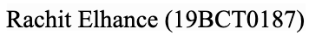

# **Demonstration of Wireless Access to Batteryless and Antennaless Sensors Distributed on Clothes, 2019**

In this paper a demonstration was done for wireless access to batteryless and antennaless sensors distributed on a conductive textile.

A double-sided conductive textile was used as a power and signal transmission bus. The two conductive surfaces were isolated from each other which work as a transmission line that conveys dc power and radio-frequency (RF) signals simultaneously. Also the system was presented with distributed temperature sensors, humidity sensors, accelerometers, and electromyography sensors, monitoring body status with sensors distributed over the body surface that could provide much more detailed information about patients' biological events.

In papers it talks about in order to distribute sensors on a human body surface with-out compromising comfort and durability an approach that could be taken is embedding those sensors into cloths using e-textiles.

It demonstrates wireless access of battery-less and antennaless sensors distributed on a double-sided conductive textile. Batteryless sensors were powered via the conductive textile, and the sensor data were transferred simultaneously via the same textile. Sink microcontroller (MCU) was then loaded with a wireless interface such as WiFi and Bluetooth, and it was operated as a gateway of the data transfer to the outside of the textile. In this paper demonstration was done with a prototype experimental setup.

The two conductive surfaces of the double-sided conductive textile( the inner and outer sides of the jacket) were isolated from each other so that voltage can be applied between them. Data of sensors were then transferred as I^2C-format bitstream, with initiation by the I2C master.Two RF carriers of 20 MHz and 50 MHz were modulated with the clock (SCL) and data (SDA) signals of I2C. The carriers were then supplied by the master device, and each slave was not loaded with its own carrier generators.

The master then interrogated each slave one by one, and the temperature data was transferred from the slave to the master. The master MCU was then loaded with a WiFi module that could also be operated as a web server that provides the sensor data on the web page.

The proposed scheme is not limited to temperature sensing. The two-carrier FDM communication on a conductive textile is compatible with off-the-shelf I2C-interface ICs. The proposed system enables reusing such well-engineered functionalities that were implemented in the ICs. Therefore, the proposed scheme could be widely used for wearable systems at low cost.

# **Low Cost, Eco-Friendly, Homemade, Graphite on Paper-based Wearable Temperature Sensor, 2019**

This paper presents a low cost wearable temperature sensor for health monitoring made of graphite.

Paper has been used as a substrate due to its flexibility, low cost and availability. The research paper involves the usage of cellulose paper (Sticky notes) for the fabrication of wearable sensors. Graphite (because of its biocompatibility) is mixed with ink to act as a conductive paste to be used for the sensor.

For the preparation of conductive paste, the composition of graphite and ink gel was 8g/ml where ink is just used as a binder. Resistance of temperature sensor deems to be proportional to the quantity of graphite in conductive paste. For getting a low resistance patch, the ratio of graphite powder and ink gel pen can be increased and thus can be decreased for high resistance..

The paste is painted on the paper using a paint brush within the defined structure of the temperature sensor on the paper. For high resistance temperature sensor requirement, thinner layer can be painted and a thick layer of conductive paste can be painted for low resistance temperature sensor requirement. Resistance can be tested with the NI-Elvis board. An iron plate is used for changing the temperature of the sensor patch. Temperature sensor patch is attached to the iron plate using the electric gun. A temperature sensor module TPM-10 is used for measuring the temperature of iron plate. We used two copper wires for the connection of temperature sensors with the help of packaging tape.



Results for various models were taken. Some were painted with a single coat and a few with multiple coats, varying the area of the temperature sensor patch. The resistance of the temperature patch decreases due to body temperature. The resistance properties of temperature sensors change as a function of temperature.

The fabrication, characterization, and response of the temperature sensor are shown in this paper.

Advantages - For the newly developed sensors today the cost of fabrication is high and requires special manufacturing labs, this model uses a low cost fabrication, Polymers are comparatively expensive, thus we use paper which still is very flexible.

Disadvantages - Environment factors might be able to alter the results.

1. **Highly Sensitive Charge-Coupled Device-based Flexible pH Sensor for Wearable Health Care Application, 2019**

This paper shows One difficulty to form the CCD structure on a flexible film is the semiconductor junction due to thermal budget issues for doping injection into semiconductor films. So in this paper a schottky junction is proposed which can be controlled by an external gate bias.

The paper introduces that Real time daily health monitoring devices can be really helpful for the patients. We need chemical substances to make these healthcare devices, which also works on other aspects like temperature, heartbeat, etc. The first way that could be done using blood to know health conditions. But taking blood invasively on a daily basis can cause infection and serious health problems compared to hospitals, so because of that the chemical substance that could be used is sweat from skin for noninvasive health check. There have been some developments for flexible sweat sensors but to precisely monitor a variety of chemical changes in sweat, higher sensitivity is required. So in this paper the authors propose a flexible pH sensor with CCD structure (helps in enhancing sensitivity) An amorphous n-type InGaZnO thin film is used as the semiconductor channel materials.

Applying an extended sensitive electrode(keeping in mind sweat does not come in direct contact with the transistor). The electron transfer injected from input is controlled firstly by the input control gate voltage and then by the transfer gate voltage, and these transport processes are controlled by pulse voltages applied to input and transfer gate. As a last step, a transferred electron is accumulated in a capacitor.

After repeating this cycle several times, reset voltage is applied to release the charge in the capacitor to measure pH value repeatedly.For the fabrication processes paper shows with the help of diagrams that for all the components used for the device structure. As a result, fundamental electron transfer and accumulation processes as the CCD were confirmed, output voltage was increased stepwise by repeating the cycles. Three types of solutions were prepared with different pH values. The solution-based temperature sensor consisting of CNT-SnO2 composite ink was printed on a PET film. The sensor resistance is almost linearly changed as a function of temperature, which sensitivity is extracted from the line fitting to be ~0.46 %/°C. The output voltage difference was larger when increasing cycles at lower pH solution from pH11.2 to pH2.8 real-time sweat pH and skin temperature monitoring was successfully conducted by attaching the device on an arm, the result showed that the product can play an important role in development of multi functional flexible sensors.

# **Development of Low-cost Wearable Walking Pattern Recognition System using Inertial Sensors, 2019**

In this paper the researcher is aiming to develop a low-cost wearable walking pattern system using inertial sensors.

This walking pattern system thus can be used to detect the walking cycle in the sagittal and frontal axes, if they develop this system more than it can also distinguish forward and backward movements.

As the paper explains that there are many benefits of regular walking such as improved treatment of many diseases and pains, improving the health-related quality of life most importantly for elder people.

Also the walking abnormalities cause severe injuries in elderly therefore, it is important to recognize the walking patterns.

The aim of this paper is to develop a low-cost wearable walking pattern system using inertial sensors. 

As per paper the walking pattern system was designed using seven inertial sensors.

Three of the sensors were installed in each leg i.e. in right femur, right tibia, right

foot, left femur, left tibia, and left foot, then one inertial sensor was installed in umbilical and used as a reference point.

This system measured the deflection angle between hip bone and femur, femur and tibia, tibia and foot in both sagittal and frontal axes from two legs.

For this system, the MPU-6050 module was chosen then the control unit in the proposed system consisted of 2 microcontrollers, ATmega328 and ATmega16U2.

The output from the microcontroller was then stored in the Comma- separated Value (CSV) file because it can be opened and edited by any text editors and spreadsheet.

Output of this process was graphs of the walking pattern in frontal and sagittal axes.

As a result the system was tested on five healthy subjects. Analysis of the walking pattern signals from the subjects showed that there were no striking features to distinguish between the subjects.

To conclude the walking pattern system can be used to detect the walking cycle in the sagittal and frontal axes. This study presented the preliminary prototype and result of the walking pattern system recognition using low-cost electronics components and modules. Paper also shares the Further development of the system that will focus to increase the variety of the subjects and make the system as wireless connection to address the cable length limitation that affects the subject movements.

# **Design and fabrication of an ubiquitous, low-cost, and wearable respiratory bio-sensor using ionic soft materials, 2019**

With the ongoing issues like heavy pollution and presence of toxic gases in the environment, the need for keeping a check on lungs to be healthy becomes a necessity, especially in old people. This paper presents an ionic electroactive polymer based soft sensor which is responsible for carefully detecting the breathing patterns.

The sensor is made of a small strip of Ionic Polymer Metal Composite that is fabricated using a Nafion membrane and platinum electrodes. IPMC actuators are electroactive polymers or smart materials that can produce large deformations in the presence of a low input voltage. Thus, when the voltage is applied, the cations flow towards the cathode, increasing the Nafion inflation in the cathode side, leading the IPMC to bend towards the anode side. Inversely, A low voltage is generated due to the bending between the two electrodes.

In the model, IPMC will be bent in response to breathing signals and produce appropriate and breathing correlated voltages that we can interpret and so we can detect the breathing pattern using these signals. The model requires the following chemicals and materials : Hydrochloric acid, Tetraammineplatinum chloride hydrate, Sodium borohydride, hydroxylammonium chloride, ammonium hydroxide, Nafion per fluorinated membrane, monohydrate and hydrazine ,hot glue, krazy glue, Cu sheet, wires and plastic pipe. The conventional fabrication process of IPMC actuators involved - pre-treatment, surface roughening, and cleaning, ion-absorption, primary electrode plating using reduction, secondary plating (reduction again), ion-exchange. To fabricate the IPMC soft sensor, Nafion 117 was used as the membrane that has been coated by two Pt electrodes using the procedure mentioned. The fabricated IPMC sensor is a 27.5x5.2x0.2 mm3 stripe and has been embedded to a mouth diameter size pipe.The system is simple. We get a voltage in the order of mV from the sensor, which is read by an analog to digital converter model ADS1256 controlled by an Arduino board. The data is obtained and sent using the Python programming language through a USB serial port. During experimenting, seven stages were planned for the subjects including normal breathing, fast breathing etc. The patterns obtained were pretty accurate with respect to the assigned stages.Thus in this paper a biosensor to measure the flow of air inhaled or exhaled was fabricated and implemented successfully. Its flexibility and sensing resolution made it a great choice for a wearable soft sensor. Advantages -Ionic sensors can perceive more details due to their flexibility and high sensitivity than piezo sensors

# **Wireless Wearable Magnetometer-Based Sensor for Sleep Quality Monitoring, 2018**

During a respiration cycle, breathing is characterized by an upper body activity, which involves a displacement of the thoracic rib cage. Especially during intense physical activities, the entire ventral cavity compresses and expands. Simultaneously, the abdominal cavity is pushed by the diaphragm contraction, moving the abdomen forward. An inertial measurement unit (LSM303DLHC from STMicroelectronics) measures the thoracic and abdominal cavity movements, by reading the corresponding variation in the magnetic vector in real-time. During breathing, this magnetic vector rotates due to the chest movement. This rotation changes one of the three magnetic vector components, which is detected by the sensor. During regular breathing, the body movement moves the sensor, located on the chest, about 4mm from its original position. The average chest wall displacement is detected by the magnetometer sensor that shows a significant variation of the magnetic field, which allows distinguishing the waveform of breathing as described in section IV. LSM303DLHC contains a magnetic field full scale of ±1.3×104 to ± 8.1×104 μT. According to previous works, it has been found that the Z-axis component of the magnetic field (perpendicular to the board) is the most sensitive to chest movement. This displacement causes a change of magnetic field power of around 0.2 μT in the direction of the shift, which is detected and recorded by the sensor. In addition, any different body movement is even easily identified, giving more information about the state of sleep.

RFduino is an integrated system-on-chip (SoC) based on the nRF51822 chip from Nordic, which can receive data from a magnetometer sensor through the I2C bus and communicate it by using Bluetooth to a smartphone. RFduino is entirely programmable by using Arduino API. The communication is performed via a Bluetooth low-energy transceiver. The RFduino module elaborates data, obtained from the breathing sensor, and extracts three parameters: respiration rate, apnoea periods and movement time. The smartphone receives these parameters and uploads them to a custom IoT database for analysis by a specialist. The smartphone can also display the data in a custom made app.

The feasibility of a wearable device to detect apnoeas and breathing rate based on a magnetometer sensor has been presented and tested. A magnetometer has been fully integrated into a small wearable device with wireless capability. An algorithm for calculating respiration rate has been presented and applied to the data from the magnetometer and compared for verification to an airflow sensor based on a thermistor with excellent results. An increase of battery life has been demonstrated by applying an ad-hoc algorithm.

# **WE-Safe: A wearable IoT sensor node for safety applications via LoRa, 2018**

This paper shows a wearable Internet of Things (IoT) sensor node made for monitoring harmful environmental conditions for safety applications using LoRa wireless technology.

As the paper explains high CO2 levels can cause headaches, dizziness and a range of detrimental symptoms whereas CO is toxic to humans when the concentration is above 35 ppm

Therefore wireless sensor network (WSN) is an efficient solution for a number of monitoring applications including building structural health monitoring, environmental monitoring,

indoor air quality monitoring.

It explains that wearable sensor nodes are essential elements in wireless body area network for monitoring the human body, they can be used to collect environmental conditions around the human body as well, such as in safety applications

This paper, demonstrates the preparation of WE-Safe Platform: a wearable IoT sensor node for safety applications via LoRa wireless technology where each of the sensor node consisted of multiple sensors, such as CO2, CO, ultraviolet (UV), temperature, and humidity sensor,

one microcontroller unit (MCU), and one LoRa module.

For this experiment the power management system includes a coin battery, a buck-boost converter (LTC3130-1), a quick-output discharge switch (TPS22918). ATmega328p was used as MCU work. It collects the data from different sensors and interfaces with the LoRa chip, then RFM95 module was used as the RF module , then temperature, humidity and pressure data were all measured by using the a BME280 sensor, CO2 was detected using COZIR CO2 sensor, CO was detected using ULPSM-CO 968-001 from SPEC sensor, then SI1145 from silicon lab was chosen for UV sensor and MySQL database.

As a result of the experiment in the paper the power consumption of the wearable node was shown, it also showed the screenshot of the mobile application developed for WE-Safe nodes, where users could view the surrounding environmental information directly.To conclude the paper some sample environmental data was collected by a wearable WE-Safe node and sent to the remote cloud via LoRa network. The aim of this WE-Safe paper was to provide early warnings for people working in extreme and harsh environments when they are not in the safe zones.

# **Recent Advances in Smart Wearable Sensing Systems, 2018**

With the development of artificial intelligence and Internet of Things (IoT) Smart Wearable Sensing System (SWSS) has attracted wide attention due to its characteristics of multifunctional, superintegration ultra-miniaturization. However, wearable sensors currently face great challenges because they need to be integrated into the proper shape surfaces with compatibility, durability, and abrasion resistance. In addition, smart wearable sensing requires complex sensing systems, which can complete a variety of functional electronic components, including data acquisition and processing, equipment operation control, intelligent data display, and self-powered operation. SWSS has evolved over the years as the ability to process large amounts of information in real time grows rapidly. Emerging technologies aim to fabricate electronic circuits on “soft” substrates to construct SWSS with unique characteristics, such as great conformability, excellent stretchability, low cost, and low weight. Flexible sensors can capture target analytes more effectively and produce high-quality signals. In general, the key factor of the SWSS is to respond quickly and accurately to the detection target and then transmit the processed data to the user in an easy to operate display mode.

Several key parameters that must be considered when developing SWSS based on the application:

1) flexible/stretchable substrates and conductors, 2) sensing materials, 3) wireless communication and display, and 4) power supply. Therefore, SWSS can be divided into several functional modules, including signal detection, processing, analysis, transmission, and display modules.

Benefitting from advances in materials, computing, and manufacturing methods, SWSS are considered as excellent candidates for practical electronic applications, such as human–machine interface, artificial intelligence, and health monitoring. In particular, wearable sensing systems will be beneficial to strain measurement of software robots.

Practical and emerging applications still face enormous challenges. First, biocompatibility of flexible substrates and active materials, including long-term toxicity analysis, is a key research area for wearable sensing systems attached to human bodies or their organs, especially for invasive applications. Second, one of the challenges in integrating sensors into wearable systems is the cross-sensitivity of different sensors. One sensor may respond to multiple stimuli, making it difficult to identify the exact type of stimulus and the intensity of each stimulus. Therefore, it is necessary to study new sensing mechanisms with low cross-sensitivity and effective decoupling algorithms. Finally, printable and textile for wearable electronic devices as a new opening will be concerned. Highly unified, good flexibility, and large-scale sensors can be fabricated directly by printing technologies to realize fully printable electronics in the future. 

# **Medical activity monitoring for elderly people using wearable wrist device, 2018**

In this paper it discusses the design and implementation of a wearable sensor based framework for medical activity recognition of elderly patients. As the paper explains that Dementia among the elderly is steadily increasing and hence, there is a need for providing efficient healthcare services for their betterment. This paper aims at building a robust and non-intrusive system for wirelessly monitoring medical based human activities using wearable accelerometers embedded in a wristband.

The system in this paper, distinguishes various medicine intake based activities with higher accuracy and lesser training data. In this experiment all the caretakers or health care officials are alerted with the help of SMS about these activities. Using this system, the caretakers were informed about the periodic medical related activities performed by patients, and hence the need for doctors could be avoided.

In this project A wristband was chosen for embedding the sensor because it was comfortable and easy to wear on a daily basis, especially for the elder people. In this paper, a dataset of 5 medical based activities were collected from the tri-axial accelerometer.

Accelerometer data were collected using a \Arduino UNO, accelerometer ADXL335, NRF24L01 transceiver and rechargeable battery.

Datasets were collected from 10 subjects with varying age, height and weight, with the help of 5 activities, i.e opening a pill box, popping a pill in the mouth, drinking water, taking medicine in a syringe and self-injecting. Snaps were then taken during data collection of these activities

As per the result of the project in the paper it was classified into, true positives p t , true negatives nt , false positives p f and false negatives nf of the system . These were used for calculating standard classification metrics like recall, precision, specificity, F-score and accuracy of the system.

To conclude this paper the arduino based framework was made that automatically detected medical based human activities and sended messages to the caretakers using GSM modem.

In this paper Time, frequency and HHT based features were then calculated from a tri-axial accelerometer.



As a result of all the experiments. three standard classifiers were analysed and it was found that SVM performs better than other classifiers. As a result, an overall accuracy of about 95.33 % was obtained using this framework, described in the paper.

# **Literature review on wireless sensing-Wi-Fi signal-based recognition of human activities, 2018**

# 

A novel wireless sensing technology is gradually emerging that can realize gesture recognition, human daily activity detection, identification, indoor localization and human body tracking, vital signs detection, imaging, and emotional recognition by extracting effective feature information about human actions from Wi-Fi signals. These available wireless sensing systems can be used in many applications such as smart home, medical health care, search-and-rescue, security, and with the high precision and passively device-free through-wall detection function. This paper elaborates the research actuality and summarizes each system structure and the basic principles of various wireless sensing applications in detail. Meanwhile, two popular implementation schemes are analyzed. In addition, the future diverse application prospects of wireless sensing systems are presented.

Based on the analysis in this work, all implementation schemes of the wireless sensing technology are based on the basic principle that the wireless signal carries rich information about human activities due to signal propagation that is affected by human actions in the wireless signal coverage space. Therefore, how wireless sensing technology could bring effective technical solutions to many fields in which there are key common points that are related to human action recognition was determined.

To put it into a complex practical application environment to use, the following categories of problems must be addressed: (1) Although they have been proven to have satisfactory accuracy and robustness, the current wireless sensing systems are only directed at experimental results in a limited controlled space. Experimental results demonstrate that the placement scheme of detection equipment, the relative distance between the detected users and devices, the multi- person complex environment, and the through-wall detection all seriously impact the accuracy of the system. Therefore, the first issue that must be solved is that wireless sensing systems are required to have robustness and reliability in complex real-world environments while ensuring accuracy.

(2) The innovation of the wireless sensing system based on the CSI helps realize the recognition perception function using the ubiquitous Wi-Fi signal. However, the IEEE 802.11n standard Wi-Fi signal is the only current option for these schemes. As mentioned, more advanced wireless technology will optimize and improve the performance of wireless sensing systems. Therefore, the second issue that must be solved is that this technology must consider the compatibility issues of protocol standards for Wi-Fi signals such as the IEEE 802.11ac and 802.11ah standards to fully use their performance advantages. Therefore, to improve the advanced wireless technology, the performance of the wireless sensing system will be further improved in the next research phase. 

1. **Energy Harvesting using d 33 Mode by Insole Embedded Low Cost Piezo- Sensors, 2018**

This paper researches the feasibility of harvesting energy using D33 mode from low cost ceramic PZT sensors of different sizes and shapes, locally available in the market.

As per paper energy harvesting can be done, from solar energy, wind energy, wave power, etc. But energy harvesting from human movement is considered to be one of the most attractive approaches to power wearable devices and replacing batteries.

Numerous research has already been done in harnessing human energy for powering wearable gadgets but as we know almost all of the commercial wearable devices are still to this date powered by a coin cell battery. Piezo ceramic sensors such as PZT patches operates in two mode i.e. d31 (length) mode and d33 mode (thickness), so basically This paper was based on the work carried out in Master’s thesis which basically researches about the feasibility of harvesting energy using d33 mode from low cost ceramic PZT sensors of different sizes and shapes, locally available in the market.

There were three types of sensors procured from CEL. These sensors were sandwiched by a layer of epoxy, i.e. Epoxy Jacket Sensors then the uneven surface of the sensor was flattened and smoothened using a grinder. Then the fabricated EJS were then embedded into the sole of the shoe at two positions which were at the ball and at the toe. The paper experiment was then conducted in the two laboratories of sizes 20 mm and then 25 mm sensors and by both the subjects and the reading was acquired across 1 MΩ resistance using the Power Measuring Device.

Further in this paper it was observed that the average power was higher in the toe region in comparison to the heel as the same was observed for peak open circuit voltage.

As a result it was concluded that The EJSs which were attached in the sole gave good results as the pressure applied on the sensors were uniform. 

Then in another research paper, Three different subjects were selected, with three different weights and BMIs. Each one of the people then were made to wear the shoe with insole embedded EJSs at the foot and ball of the shoe, after this all of the people were then made to run on a treadmill (same for everyone) and the readings were then noted.

As the result and analysis from all the experiments done in the paper it showed that the 25 mm dia disc ceramic sensor was the best suited for energy harvesting by human motion by d33 effect as it generated more power than the 10mm and 20 mm dia sensors. It was also determined that the sensor was surface bonded to the sole and embedded within the sole of a shoe.

# 

# **A Survey on Activity Detection and Classification Using Wearable Sensors, 2017**

Activity detection and classification are very important for autonomous monitoring of humans for applications, including assistive living, rehabilitation, and surveillance. Existing activity monitoring systems can be broadly classified into two categories based on the manner in which sensors are employed in an environment:

(1) fixed sensor setting, where information is gathered from static sensors mounted at fixed locations: Fixed-sensor approaches involve acoustic , vibrational, other ambient-based sensors, or static cameras installed at fixed locations. This type of activity monitoring is confined to limited environments, where the sensors are installed, and usually involve the installation of specialized sensing equipment.

(2) mobile sensor setting, where the sensors are wearable and thus mobile: The alternative to fixed-sensor settings for activity monitoring is mobile sensing, where the sensors are wearable and activity is monitored in a more first-person perspective. There is a large body of work using A/M/G sensors for activity classification. Accelerometer-based systems have been proposed for fall detection. There are systems using single sensor accelerometer-based systems and those fusing several sensors to detect ambulatory-type activities. Others are performing posture recognition . A/M/G-based activity recognition systems have been divided into two main sections, describing A/M/G-based systems focusing on global body motion type and local interaction type activities, respectively. 

Initial orientation-based sensing approaches started with stable sensors at the waist and classified a limited set of activities. These approaches additionally saw improvements and can be distinguished from one another in terms of the increasing feature sets used. Moving these orientation sensors to the extremities also enabled the ability to approach new activity types that involve more localized motions such as brushing teeth, vacuuming, and so on. However, orientation based sensors are limited by the information they provide, and with improvements in the camera technology, others have been able to show that cameras can provide details that these other orientation sensors cannot. That is, images and videos can provide more detailed information and context for a specific action sequence, and not only be able to distinguish between making food, but also making specific types of food. Yet, despite the additional activities these camera only systems can tackle, the accuracies of these systems, often below 60%, are far lower than other works discussed. Hence, more recent hybrid works have provided the ability to classify both global and local activities, while maintaining higher accuracies of above 80%.

# **A wearable 3D motion sensing system integrated with a Bluetooth smart phone application, 2017**

This paper introduces a motion sensor which works on the sensing mechanism based on magnetic and inertial measurement units. It transmits the data to the mobile phone application using Bluetooth protocol.

The BNO055 system in the package is used to achieve absolute orientation sensing. It integrates tri-axial 14-bit accelerometer, a tri-axial 16-bit gyroscope, a tri-axial geomagnetic sensor and a 32 bit microcontroller, which runs a fusion algorithm to convert raw data of the three sensors into absolute 3D orientation of an object in form of Euler and Quaternion angles. The model chooses to go with Quaternion angles as Euler format suffers from the problem of gimbal lack.

For communication, a transceiver chip is used from a Nordic Semiconductor which works on the Bluetooth low energy protocols. BNO055 sensors use I2C serial protocol to communicate with the transceiver chip. 2 PCBs are fabricated. First of incorporates an orientation sensor along with the BLE transceiver chip while the other board contains only the orientation sensor. I2C lines connect the PCBs together, which in turn is the communication bus through which the transceiver extracts the sensing data from each sensor chip. For flexible orientation sensing, the PCBs are sewed onto the flexible arm sleeve using a conductive thread where PCB1 stays on the upper side of the elbow and the other one stays on the lower side.

The mobile application has been developed in such a way that the data packets are used to replicate arm movements.

The proposed system is well implemented and can be used in different industries. It works on a fully charged LiPo battery. It can be used in the fields of sports for training athletes, or gym to rectify the quality of exercising angles and postures. It can also be used in the gaming industry.

Advantages -

Uses Quaternion angles instead of Euler format , Can be used in many industries to improve quality of exercising angles and postures, Visual Representation of motion is present in mobile application

Disadvantages - Not a very long lifetime, Communication reach is limited 

# **Recent advances in wearable sensors for health monitoring, 2015**

* This paper discusses recent advances in wearable sensors and systems that monitor movement, physiology, and environment, with a focus on applications for Parkinson’s disease, stroke, and head and neck injuries. Ubiquitous healthcare systems take advantage of a large number of hardware and software components, including Wireless Body Area Networks (WBANs), mobile devices and wireless cloud services, in order to achieve pervasive delivery.

A systems approach is needed to

:- integrate sensors with safety,

:- secure and timely collection,

:- dissemination and interpretation of data related to health status.

It also highlights that the role of user and decision-maker may or may not overlap.

Wearable Sensors:

Activity Monitors:

* The incorporation of multiple sensors including accelerometers, gyroscopes, goniometers, force sensors and pressure sensors can provide more detailed insight into movement characteristics such as gait, falls, tremor and dyskinesia. Capturing the full range of human motions in a stretchable, nonrestrictive design and seamless integration with other system components are challenges that need to be addressed. Spray-on sensors, and self-healing polymers are two examples of advances that may address some of the challenges with existing approaches in the longer-term.

Physiological Monitors:

* For EEG, ECG and EMG capacitive sensors are typically used to measure biopotentials, while for vital sign optical detection techniques such as piezoelectric strain sensors are generally used.
* :- The commercial availability of patch-based wearable sensors represents a significant advancement in personal monitoring device design, functionality and wear time.
* :- Flexible, temporary transfer tattoo-based sensors, or “electronic skin” or “epidermal electronics”, show great promise for analyzing metabolites
* :- For chemical analysis, one of the long-term goals is to realize lab-on-a-chip approaches that can analyze bodily secretions, such as sweat and saliva. Real-time sweat analysis can provide information on pH, electrolytes and hydration, and there have been efforts to build flexible, textile based systems.



* :- Biosensors that identify biological molecules or pathogenic organisms are of particular interest for studying complex processes. The ability to detect hormones, enzymes, or lipids would greatly assist in monitoring organ function, viral or bacterial infections, and metabolic disorders.

Environmental Monitors:

* Environmental monitoring is critical both for adding context to activity and physiological measurements, as well as monitoring hazards. Wearable sensors that are able to detect exposure to contaminants such as explosives, viral DNA, radioactivity or high concentrations of toxic gases like carbon monoxide, and monitoring of pollutants such as heavy metals, allergens such as pollen.
* The analysis of volatile organic compounds (VOCs) in exhaled breath samples can potentially provide valuable information regarding the progression of some illnesses. While most of the technology involved in volatile-compound detection methods is bulky and expensive, the development of micro- and nano-scale technology has dramatically increased the sampling capabilities of these sensors.

Medical Use Cases:

Parkinson’s Disease:

* Machine learning algorithms are typically used to analyze the **complex and unpredictable characteristics of wearable sensor data(due to overlap of normal activities and movement disorders)** in order to study tracking of movement disorders in PD patients.
* Keijsers have utilized static neural networks to detect dyskinesia from accelerometer sensors worn by patients diagnosed with PD. The patients carried out scripted activities in a randomized order; however the temporal resolution was limited to 1 minute. Salarian have used tri-axial gyroscopes to detect tremors on a per-second basis from subjects who were made to perform a scripted sequence of activities.

Stroke Management:

Tracking changes in motor function can be used as a feed- back tool for guiding the rehabilitation process. Uswatte, made patients wear accelerometers on both wrists for a period of three days. The results indicated good patient compliance and showed that the ratio of activity recorded on impaired and unimpaired arms, gathering clinically- relevant information about upper extremity motor status. Prajapati performed a similar study for the lower extremities, using two wireless accelerometers placed on each leg. They used Wolf Functional Ability Scale (FAS), to analyze the activities, which is very similar to daily normal activities. 

Head and Neck Injuries:

* Reduction in the range of motion of the cervical spine has been found to be a useful indicator of physical disability in neck pain and a predictor of poor outcome after whiplash injury. A new generation of wireless orientation uniaxial accelerometer and a magnetometer, in each orthogonal axis.

# **Fall detection analysis with wearable MEMS-based sensors, 2015**

Abstract-Accidental falls are frequent and dangerous events for the elderly population, which can result in serious injury or fracture of bones especially hip bone injury or other joint fractures. There are several methods for detecting falls of elderly, such as camera-based, personal emergency response System (PERS), and wearable sensor-based. However, the camera-based method is limited by instrumented spaces and the PERS suffers from inability to give an alarm after a fall. The wearable sensor-based fall detection is not limited to instrumented spaces, moreover, it is easy to detect the falls through tracking the kinematic information about the monitored person. In this paper, a wearable Micro-electromechanical Systems (MEMS)-based sensors module is designed for fall detection including one three-axis accelerometer, one three-axis gyroscope and one three-axis magnetometer. However, falls from activities of daily living (ADL) make it difficult to distinguish real falls from certain fall-like activities such as sitting down quickly and jumping. An approach is proposed using attitude angles to reduce false falls through tests of static postures and dynamic transitions. Meanwhile, the proposed method has real-time response and high computation efficiency.

A wearable electronic module is designed with commercially low cost MEMS-based sensors

A. Fall Detection Approach

In this paper, the three attitude angle pitch, roll and yaw are used for fall detection. At the same time, the nom of accelerometer and gyroscope Kalman filter is applied for attitude determination by fusing the collecting data from accelerometer, gyroscope and magnetometer.

B. Fall Detection Tests

The wearable electronic module was fixed on the chest to carry out the three tests: ADL, fall-like activities and fall activities. Test 1 is the ADL experiments. The activity sequence is walking, running, walking upstairs and walking downstairs.

C. Conclusions

From the three tests with wearable electronic modules fixed on the user chest, the accelerometer-based and gyroscope- based fall detection methods can be considered as simple methods. Through comparison between fall-like activities such as sitting quickly and lying down quickly and real fall, we know that the accelerometer-based and gyroscope-based fall detection methods are not quite reliable. The attitude angles for detecting fall proposed in this paper are complex. However, the attitude angles for fall detection can prove falling direction and quantified analysis of the falling of elderly.

# **Design of a wearable sensing system for human motion monitoring in physical rehabilitation, 2013**

The researchers aimed at developing a WBAN system that is comfortable to wear, easy to use,

apply and reapply, as well as non-limiting for the body movements and acceptable to clinicians. This type of system has a wide range of applications in several fields but the focus of their paper is on physical rehab.

They proposed a prototypical system composed of wearable sensors, which has features like Wireless communications, Correctness of data, Real-time operation, Portability, Easy manipulation, automation and a friendly GUI.

The system proposed the use of inertial sensors like MEMS (Micro-Electro-Mechanical Systems).The researchers have done numerous tests and have even gotten detailed reports on stuff like jitter, battery life, activity classification, pose recognition etc.

The system they created operates in real time and in a wireless network, guaranteeing data correctness while being portable and easy to manipulate, which are crucial factors for the target application. In addition, it provides software with a GUI for easy management of the sessions.

They have also tested system functionality for analyzing the data acquired and aiding in the tasks of activity classification, pose recognition and exercise assessment using different techniques, from standard classifiers to Fuzzy Finite State Machines.

Advantages of the system: The system uses multiple sensor modules so the system can more accurately discern the correct body posture of the patient. And use of a firm IEEE model helps them have an efficient data analysis model.

Disadvantages: The system, even though it has been successfully working, is too large and isn’t much cost effective right now and a miniaturization should be done. The data shown is not well detailed yet and there isn’t a model to depict the exercises in the linguistic form.

# **A wearable sensing system for tracking and monitoring of functional arm movement, 2011**

This paper presents a design of the OLE-based system for the function of capturing human arm motion.This works in a way where the encoder counts the number of engraved lines on a reflective strip to track the travel distance. This recorded distance can be converted to joint angles.

They ran many tests to find out how efficient the model is and one of the test results showed that in an off-body comparison, OLE showed the correlation coefficient of 0.999 and a very less error of 1.2.

In the in situ test, compared with Goniometer, OLE performs the correlation coefficient of 0.990 and error of 3.8.while in shapewrap, OLE shows the correlation coefficient of 0.992 and error of 3.1.

What these numbers basically show is that the OLE system is as good and even better than the current commercial motion capture system.Using a CAN bus they joined three sensing nodes to form a sensing network which was attached on the arm and evaluated on the basis of reliability and repeatability of a particular action.With these they performed tests and found out that the system is capable of performing and maintaining its functions in routine circumstances with different biometric subjects.



The system is reliable and the team has been cooperating with Tan Tock Seng Hospital (Singapore) to develop a motion capture device based on this paper’s work for monitoring and assessing stroke rehabilitation processes.

The only disadvantage of this system is that it is fairly new and even though prototypes are made using the system it will take time to gain the trust of people.

This also allows this system to grow more and maybe in the future this may be used instead of the widely used systems right now.

# **Development of wireless sensing system monitoring physiological information for healthcare in daily life, 2011**

A wireless sensing system for monitoring physiological information in the living environment was developed. Data could be obtained in daily life without restraining wearers’ movements using multiple networked wearable sensors with a reasonable battery life. The system was evaluated for the prevention of heat stroke and unwellness during exercise monitoring real-time thermal physiological state with ambient temperature and humidity. Experiments showed that the detection of the abnormal level of physiological data and its change was effective in judging the physiological state and giving a warning on the health condition in the context of activity and surroundings.

​​The human body gives out various vital signs. Some vital signs need to be monitored with a relatively short sampling period and the data is transmitted at relatively high rates e.g. for ECG sensors. Other vital signs need to be measured no more than once a second and the data is transmitted at low rates e.g. for thermometers and blood pressure sensors. Therefore, systems should be properly designed to ensure the reliability and availability of the data.

A. Composition of system

1) Ear-worn temperature sensor Ear-worn temperature sensors were developed for continuous noninvasive measurement of core body temperature in the auditory meatus.

2) Thermo-hygrometer and skin temperature sensor: Thermo-hygrometers and skin temperature sensors were developed using the SHT1x humidity and temperature sensors, from Sensirion.

3) ECG sensor with accelerometer and thermometer An existing wearable small-sized RF-ECG from Micro Medical Device Inc. was used since its measurement accuracy has been validated. It wirelessly transmits ECG signals, as well as tri-axial acceleration and surface temperature to a wearable PC. It utilizes low power radio transmission (2.4GHz).

B. System construction

The sensors transmit data wirelessly in synchronization with each other based on the timer of the wearable PC (coordinator).

For prevention of heat stroke:- Core body temperature, skin temperature, microclimate within clothing on the chest and back, HR, amount of activity, and environmental conditions are important indicators. The thermo-hygrometer developed can be set up easily and can monitor environmental temperature and humidity. In sunny outdoor environments such as grounds that get a lot of sun, a WBGT measurement system is also expected to be installed in order to take into account the effect of solar radiation. Hence the monitoring system was configured.

# **Wirelessly accessible sensor populations (WASP) for elderly care monitoring, 2008**

This paper presents an application responsible for constant monitoring of the elderly using wearable sensors. The WASP project aims to address health-related issues in order to provide a complete sensing system. Its architecture includes -

The body sensor network (BSN) : This network of sensors will be worn by the patient and will be responsible for collecting the user related data.

The ambient sensor network (ASN) : This network of wireless sensors will be installed in or around the house and will be collecting data regarding the patient’s environment and activities.

The personal mobile hub (PMH) : This will be a mobile phone or a PDA which will act as the hub of the body sensor network. In addition, it will be used as a data logger when the user is out of range of ASN.

The remote data collector (RDC) : This is a server which will be injected with a secure database which collects the data from the patients and homes via WSN Hub through the internet.

The wireless sensor hub (WSN Hub) : This is an abstract gateway that can collect data from the sensors directly and forward it to the RDC.

The assistance providers : These will be the employees assisting the elderly people.

WASP has a service oriented architecture whose structure includes – service identifier, service interface, service binding, service characteristics and service constraints. During implementation, ambient sensors like microphones, RFID tag, water usage sensors were used. Wearable sensors included arm bands, shoe worn sensors and ear worn sensors which include 3-axis accelerometer as well as a Pulse oximeter. Using information from both ambient and wearable sensors, the results were determined.

Advantages - Network utilization occurs at its best , Complete service oriented system.

Disadvantages - Working with ASN can be complex.

1. **Wearable Sensor System For Human Behavior Recognition, 2007**

A wearable sensor system for human behaviour recognition was introduced in this paper. It consists of various sensors used to judge if a person is walking, running, standing, eating or talking. The sensors are all connected by wireless communication.

The sensors take input parameters such as the user's location, body motion, posture, time and schedule.

The sensors involved are :

i - Foot pressure sensing shoes : It is used to measure the pressure distributions of each foot. It has seven piezo resistive pressure sensors implanted on the insole. The sensors are placed on the local centres of pressure: heel, great toe, lateral border, great ball, little ball, and both heads of arch.

ii - Motion sensing watch : The sensor has a built in accelerometer and angular rate sensor. 

iii - Sound sensing glasses : The sound sensing glasses have a microphone and an external microphone. They are used to detect speeches and masticatory movements of the user.

iv - Pen-shaped ceiling sensor :This is made up of an ultrasonic sensor that will be used to measure the distances.

Bluetooth indoor positioning system integrated with GPS mobile phones is supposed to locate the user’s position from the signal strength of Bluetooth wireless connections. Base stations installed in the area will connect to the user's mobile station and measure the signal strength as soon as the user enters. The position of the user is calculated by a three-point method. The mobile phones obtain the positions by GPS when the user is outside the area. The base station will include a Bluetooth module and microcontroller.Behaviour inference system is used for integrating the sensor data. It receives the data and translates them into intermediate elements such as posture or position. Next, it combines these partial elements into a comprehensive behavior. With the frequency of the behaviors, the system computes the probability distribution of the next behavior.

The system is validated for 75 days. 65.9% was the accuracy of the predicted behavior .

# **Wireless, low-cost interface for body area networks, 2004**

The paper focuses on developing a wireless low-cost transmission system for short distances. The system has a wide range of applications for connecting any pieces of clothing with each other.

In the approach they took Instead of directly measuring the foot orientation angle at initial ground contact, they used the time difference between initial heel and ball ground contact. This measure can easily be obtained utilizing force sensitive resistors (FSR) placed at the boot sole.

The paper goes on to show how the use of this system is feasible and has provided positive results showing that the system is working well.

Problems faced by the proposed system:

Currently, power consumption of the transmitter is still high.

Proposed solution

Through optimization, especially of the oscillator circuit, and integration in a chip power consumption can be drastically lowered.

Scope of improvement:

Transmission range can be increased by optimization of the circuit. For the locomotion sensor, a complete stand-alone system with a power generator in the boot as shown by Kymissis might eventually be possible.



**3.2 Survey Table**

| **References** | **Sensor** | **Monitored Parameter** | **Wireless Platform** | **Location** | **Battery** |
| --- | --- | --- | --- | --- | --- |
| 1 | Inertial Sensors,  RF Classifiers | Detection Classification of ADLs, GTCS, Falls | Bluetooth/Wifi | Whole Body | Rechargeable Battery |
| 2 |  | Papers related to solutions using Iot sensor networks. |  |  |  |
| 3 | Electromyography Sensors, Sock-Type Electromyography Sensors, GNSS Receiver, Liquid State Conductive based Stretchable Sensors, Conductive Hydrogel Sensor | Motion analysis,  Motion prediction,  Health analysis,  Balance Detection | Bluetooth,Wifi | Whole Body  (Different sensors  on different parts  of the body) | Rechargeable  Battery, LiPo Battery,Coin Battery,  Limited time use |
| 4 | NFC-based  Strain Sensor and Temperature Sensor | Spinal Posture and Continuous Exercise Monitoring | NFC | cervical, thoracic,  Lumbar sections of  the spine | Battery Free |
| 5 | Wristband | Movement and posture, body temperature, blood pressure and heart rate | NB-IOT | Wrist | Magnetic resonance-based wireless charging |
| 6 | Tri-axial  Accelerometer,  Inertial Sensors | Localise and track resident’s movement in the house for normalcy | Fog computing using TCP connection | Overall House  monitoring | Manually  Powered |
| 7 | Self Powered Wearable Sensor | Heart rate, Blood oxygen saturation and Body temperature | Wi-Fi | Chest | Solar Energy Harvester |
| 8 | Scanpath-trend Analysis approach(STA) | Activity Recognition using eye tracking based algorithm | - | - | - |
| 9 | Electronic bracelet-type tags, RFID receivers, Gps transmitters, Environmental sensors i.e. pressure, motion, temperature sensor and RGB depth sensor | Track pressure applied on the shoe | Signal received by wireless transmitter | Shoe | Battery less |
| 10 | Temperature sensor, sensors compatible with I2C | Track the temperature of the body | Wifi module | Jacket | Battery-less |
| 11 | Graphite on Paper-based Wearable Temperature Sensor | Body Temperature | Bluetooth | Hand | None mentioned |
| 12 | CCD-based pH sensor | Real-time sweat and skin temperature |  | Arm | Battery free |
| 13 | Inertial sensors. MPU-6050 TM | Data will be acquired through walking patterns | Serial communication protocol and stored in CSV | Legs and umbilical |  |
| 14 | Wearable respiratory bio-sensor | Breathing patterns | Signal received by ADC | Hung on the neck | LiPo Battery |
| 15 | Magnetometer Sensor, Inertial measurement unit(LSM303DLHC from STMicroelectronics) | Sleep quality monitoring using breathing pattern | Bluetooth | Chest |  |
| 16 | COZIR CO2 sensor, ULPSM-CO 968-001 from SPEC-  Sensor, SI1145 UV sensor. | Keeping track of the changing environmental data through walking | LoRa Wireless technology | Attached to clothes | Coin battery |
| 17 | Sensing materials | Human body and organs | Wireless transmission | Human body and organs | Manually powered |
| 18 | Arduino UNO, accelerometer ADXL335 | Using 5 activities involving hand | 20Hz.Wireless transceiver NRF24L01 | Dominant hand | Rechargeable battery |
| 19 | Inertial Sensors | Moment monitoring | Wifi | Whole body | Rechargeable battery |
| 20 | PZT sensor and Epoxy jacket sensor | Human body moment(walking and running) with varying weight |  | Sole of the shoe | Coin cell battery |
| 21 | Acoustic , vibrational, or static cameras,  mobile sensors | Movement tracking | Bluetooth,  Wifi | Overall body movements | Manually powered and rechargeable battery |
| 22 | Motion sensor | Motion and Quaternion angles of the arms | Bluetooth | Arm | LiPo Battery |
| 23 | Inertial sensors like accelerometers, gyroscopes, goniometers, force sensors and pressure sensors  Physiological sensors like, patch-based wearable sensors, tattoo-based sensors, environmental sensors | Activity monitoring,  Cardiovascular activity,  Sweat analysis for glucose and pH levels,  for toxic gases, viral DNAs, allergic pollens or VOCs | Bluetooth, mobile and cloud platform | Whole body | LiPo Battery |
| 24 | 1 3-axis accelerometer, 1 3-axis gyroscope, 1 3-axis magnetometer | Fall detection | Bluetooth | Overall body | Rechargeable battery |
| 25 | Genesis WiModule | Human motion | RF transceiver | Waist and knees | None mentioned |
| 26 | Optical Linear Decoder, Accelerometer. | Functional Arm Movement | Bluetooth | Shoulder, Elbow, Wrist | Rechargeable battery |
| 27 | Ear-worn temperature sensor, Thermo-hygrometer and skin temperature sensor, | Core body temperature, skin temperature, microclimate within the cloth, HR, amount of activity, environmental conditions | WiFi | Overall body |  |
| 28 | Arm bands, shoe worn sensors, ear worn sensors, pulse oximeter. | Motion of the body and heart rate of the body | Personal Mobile Hub | Arm, Feet, Ear, Chest respectively | Limited lifetime |
| 29 | Foot pressure sensing shoes, Motion sensing watch, Sound sensing glasses, Pen-shaped ceiling sensor | Fall Detection | Bluetooth wireless connection | Foot, Wrist, Eyes, On Clothes respectively | Respective limited lifetime batteries |
| 30 | Force Sensitive resistors (FSR) | Foot orientation Angle, Activity  Tracking | PDA | Sole of the Shoe | Limited Lifetime |

**3.3 Problem Definition**

Monitored structural health systems provide valuable insight into the state of the structure, enabling planners to make better decisions regarding maintenance and ensuring the safety of its occupants. This demands a need for live data sourcing from the body sensors with a vast and secure database storage. Securing such cloud services and means to send data over a secured connection is one of the problems we sought after. Database alone can not provide the structural data. The data has to be converted into different easily understandable graphs, for us to get valuable comparison data and to ensure that we can provide the service for a longer period of time with strategical improvements in the future. Creating an environment where the data can be visually presented for the user is also an integral part of this paper. The obtained data should help provide assistance in case of an emergency, encouraging us to create a secure rule-based action system that sends alerts and also contacts relevant authorities in the time of need.

Problems to solve:

* Secure data retrieval and storage of the sensors.
* Visually representing the data for better emergency response time and sensor calibration.
* Alerting the correct authorities as well as the user in case of an emergency.
* Creating an UI ; to provide live data from the body sensors over a metered distance.

**4.1 Proposed Method**

We aim to build a framework which utilizes Wearable Sensors and a smart-phone app for Smart Healthcare Monitoring System for elderly people.

The main objective of our model will be to

* + monitor the patient’s physiological data received from the sensor network,
  + upon the retrieval of data, the record is created and data is accordingly stored
  + provide the data and detected diseases to the healthcare monitoring facilities in real time
  + and provide alerts in cases of symptoms of abnormality

Our model will include the following 3 layers :

**Wearable devices (Patients Layer):** A network of wearable sensors are going to be connected to the patient's body to gather physiological data. Such sensors are measuring vital-sign, like blood oxygen saturation, skin temperature and heart-rate; a spread of healthcare sensors are available today. The data gathered is transmitted to the patient's PDA via Bluetooth device and ultimately to a cloud database through a network gateway. Moreover, sensors will operate to live and send the info regularly without patient attention to form everything automated, thus, this enhances users quality of experience and makes it easier .

**Cloud (Data Layer):** The Cloud receives patient’s data from the gateway over the web to be sorted then it becomes available for doctor’s inspections. Additionally , all data analysis and processing are going to be held within the cloud for any disorder detection in patient’s data, thus, the abnormal changes in patient’s data are going to be categories supporting patient status and diseases. All resulting data/info are going to be reported either to patient’s and/or doctor’s platform or emergency unit or both counting on patient status. Thus, Cloud enables collaboration and knowledge sharing through its infrastructure which allows medical professionals to host information, analytics and diagnostics about patients in order that other professionals around the similar interests can immediately access the info . This reveals faster prescriptions and real-time updates to patient’s data.

**Monitoring platform (Hospital Layer):** This layer may be a doctor’s platform to watch patient’s records and sensory data. The doctors are going to be ready to inspect reports provided by the system from the cloud and that they are ready to take actions. Data synchronisation during this platform in real-time by pulling all data from the cloud as soon as it becomes able to use to stay doctors up so far with patient’s status, also to assist paramedics to require early action just in case of emergency before things gets worse and stop hospitalisation.

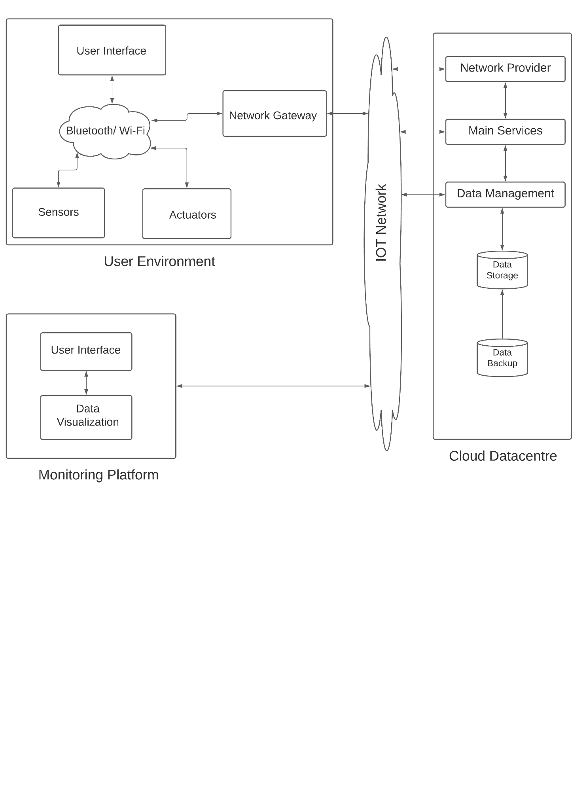

**The Wireless Sensor Network will have a star topology.**

**The main components of the model are:**

* **User Environment (wearable sensors):**
  + where all medical sensors and wearable devices are connected to patients and operated over the IoT network.
  + Each sensor/wearable (e.g., pulse sensor) has a unique identifier and communication capability over the network to interact with the gateway.
  + Data can be **bio-medical or environmental.**
  + The generated/gathered data in this layer are transmitted to the gateway via wireless or wired communication protocols, such as Bluetooth, ZigBee, and Wi-Fi.
* **Gateway:**
  + This comes under the patient's layer.
  + Perform prime processing on the sensed data.
  + Outcome of this segment is a summary of patients' conditions sent to the caregivers.
  + Gateway is also able to **react upon symptoms of abnormality** when it’s been detected, for instance, sending a help-request (e.g., request for caregiver for assistant) or **emergency-request** (e.g., call for an ambulance) as soon as an emergency situation is detected.
  + **In this research, a programmed Arduino Uno and a patient's smart-phone will be used as a gateway to prove the concept of the proposed solution.**
* **Cloud Data-center:** 
  + This segment was deployed to act on data provided from the Gateway.
  + Thus, the main data storage, data display and disease detection activity are executed.
  + This includes the machine learning (ML) activities for data training and analysis to detect diseases and abnormality.
* **Monitoring Platforms:**
  + This includes both the patient's platform and caregivers' platform.
  + Each dashboard provided for data visualization, monitoring, and functionality controls over the collected data from sensors.
  + This platform requires the level of security access alongside with different access layers, for example, patients can have the master level of access, while caregivers have restricted access according to the granted level of access.

We will be deploying our application using AWS cloud and thus the following procedure will be implemented.

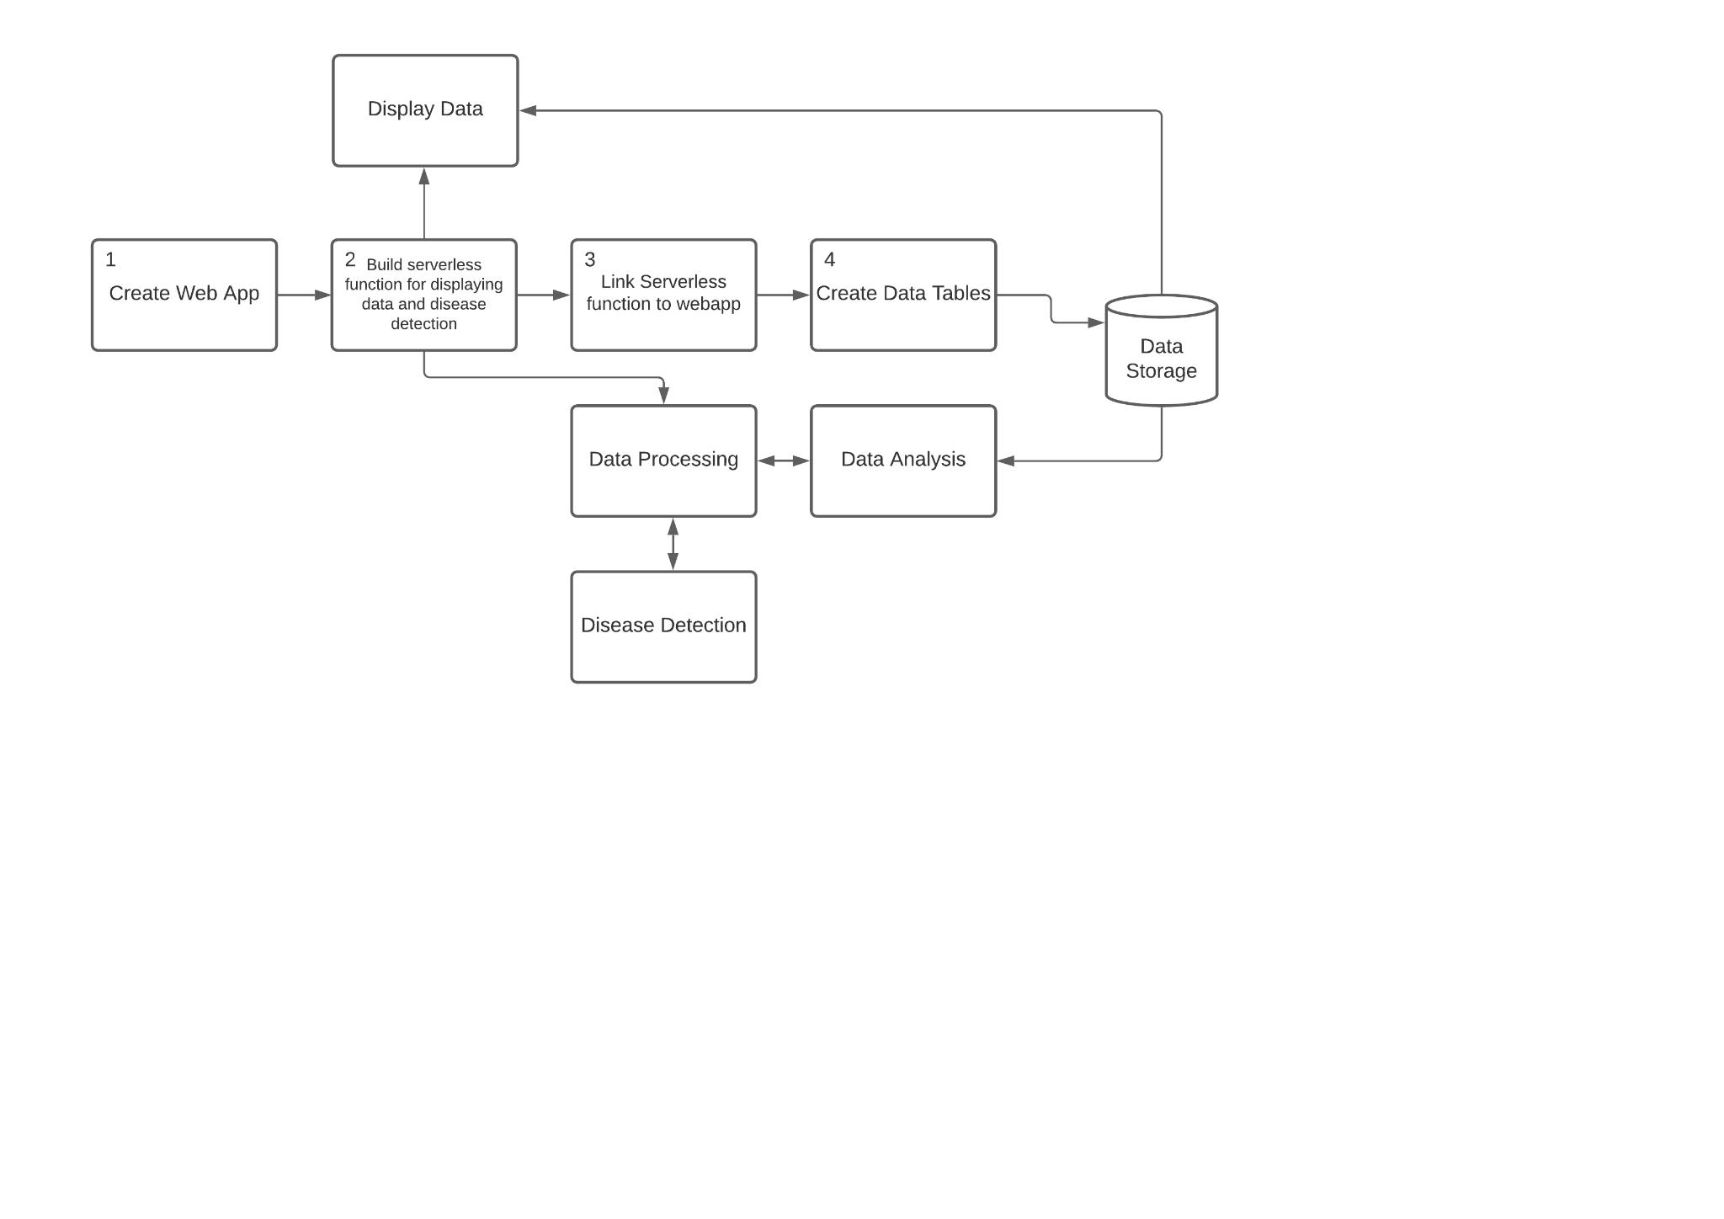

# **Sensors Table:**

| **CardioVascular System** | **Function** | **Sensors** |
| --- | --- | --- |
| **Wrist Band** | To measure SpO2, Heart rate and Body Temperature. | * Pulse Oximeter Sensor * Temperature Sensor |
| **ECG Sensor** | Constantly monitoring cardiac activity. | * Dry Sensor |
| **Patch Based Wearable Sensor** | For sweat analysis. | * Sweat Sensor * Electrochemical Sensors |

| **Motion Monitoring System** | **Function** | **Sensors** |
| --- | --- | --- |
| Fall Detection System [24] | To monitor and alert sudden falls. | * 1 3-axis accelerometer * 1 3-axis gyroscope * 1 3-axis magnetometer |

| **Sleep Monitoring System** | **Function** | **Sensors** |
| --- | --- | --- |
| Sleep Quality Monitoring [15] | To monitor sleep patterns. | * Magnetometer |

| **Environment Monitoring System** | **Function** | **Sensors** |
| --- | --- | --- |
| Wearable Thermo-Hygrometer | To measure temperature and humidity around, to predict heat strokes. | * Thermo-Hygrometer |
| Pollutant Detection System | Sensors for toxic gases, monitoring pollutants such as heavy metals, and allergens such as pollen. | * Toxic Gas Sensor * Heavy Metal Sensor * Pollen Sensor |

| **Respiration Monitoring System** | **Function** | **Sensors** |
| --- | --- | --- |
| Respiration Monitor [14] | To monitor breathing patterns. | * Ionic electroactive polymer-based soft sensor |

**4.2 Flow Diagram**

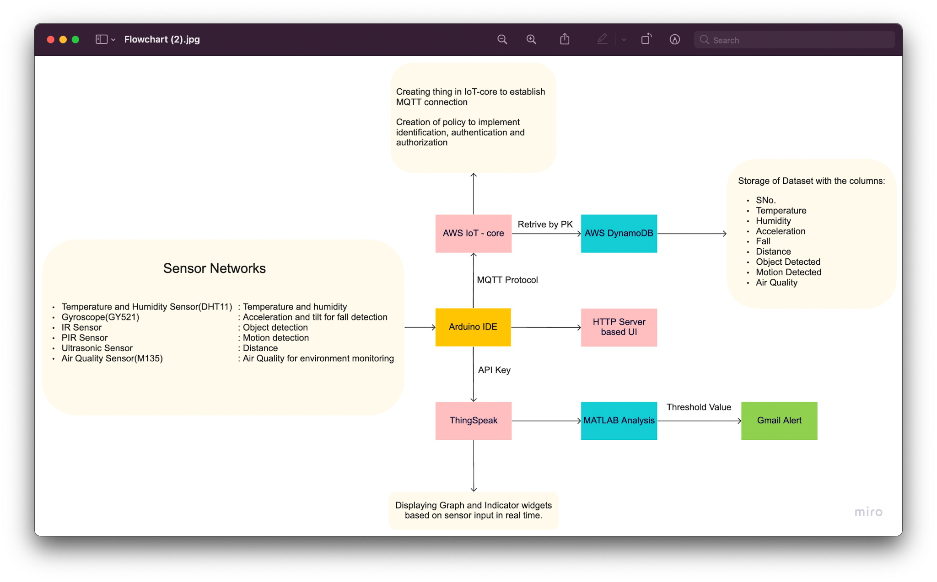

**4.3 Proposed Algorithm**

1. Including all the relevant libraries for the sensors used
   1. Adding special libraries that are included for reading and writing data we get from the temperature sensor.
   2. Adding special libraries that are included for reading and writing data we get from the Gyroscope.
   3. Adding special libraries that are included for reading and writing data we get from the Air Quality sensor.
   4. Adding the rest of the libraries that are required for server upload functions, MQTT transmissions, HTML local server transmissions, NodeMCU operations, wifi connections and for performing simple read, write activities on serial monitor and AWS, Thingspeak clients.
2. Initializing variables
   1. To send data to the Thingspeak server we create an ‘api-key’ variable and a server address variable to connect with thingspeak using its write api key.
   2. To upload data to Thingspeak and the AWS server we create variables declaring the wifi and pass. The nodemcu will connect to the wifi using the details.
   3. Initializing all the variables required for data processing and assigning variables for the GPIO pins used.
   4. Initializing broker id and wificlient to set and send MQTT to AWS server.
3. Creating a setup_wifi() to connect to the wifi. Create the following reconnect function to loop until we are connected to the MQTT server client.
4. Inside the void setup() we set up the serial monitor to print our data locally.
   1. Setting pins for INPUT and OUTPUT modes according to the sensors and their corresponding GPIO pin variables.
   2. Creating a Heap for private,public keys and certificates for the AWS Thing.
   3. Begin the HTTP local server.
5. Inside the loop() we post the data onto the Thingspeak, AWS and HTTP servers for the outputs.
   1. Get all the data from the connected MPU and perform relevant operations to get the desirable output values from the Temperature, IR(obstruction), PIR(motion), gyroscope(acceleration and axis tilt), and Ultrasonic(proximity) sensors.
   2. Segregating all the data as different field variables and sending the data to the Thingspeak server via MQTT.
   3. Uploading all the data onto the AWS server in the JSON format, to be displayed in DynamoDB, using MQTT.
   4. Locally displaying all the information on the HTTP server.
6. Closing any open connections when the transmission process is manually terminated.

**4.4 Components Used**

**Hardware Used:**

**Microcontroller:**

1. NodeMCU(ESP8266):

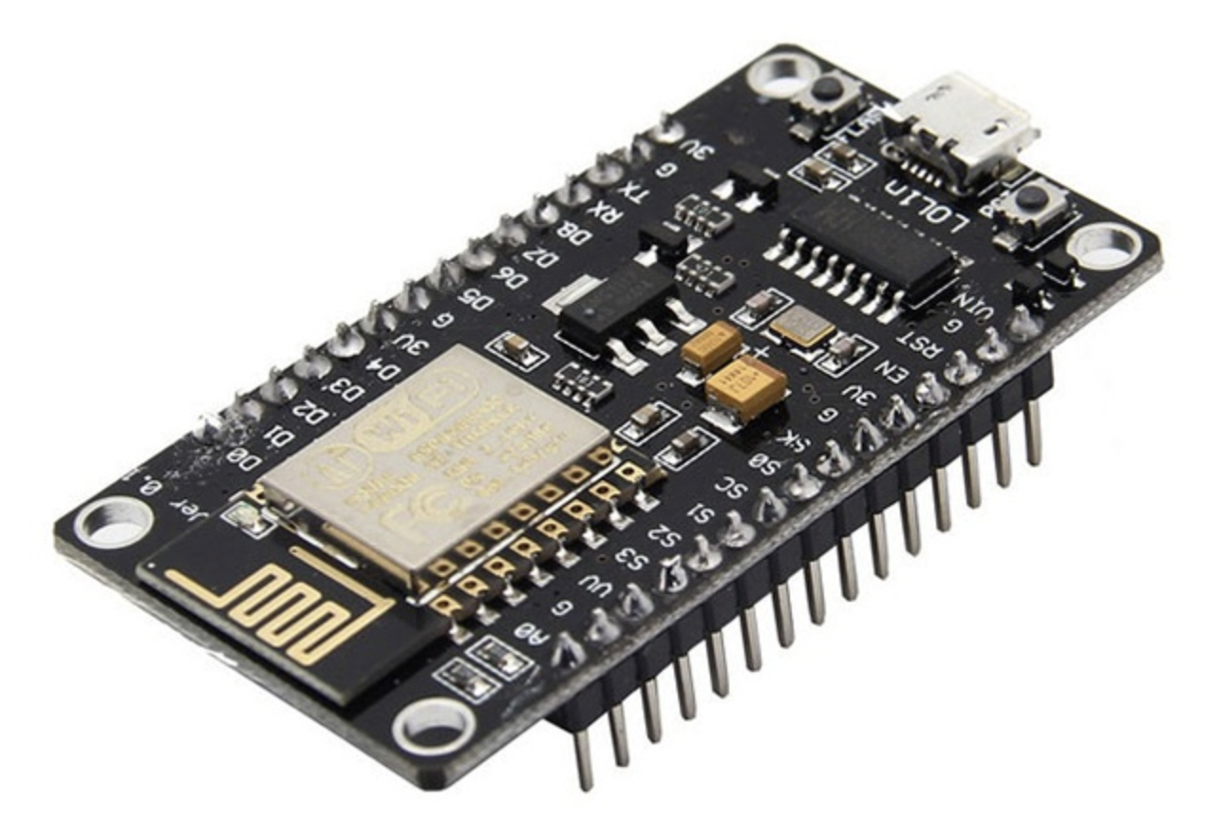

**Sensors:**

1. Temperature and Humidity Sensor(DHT11):

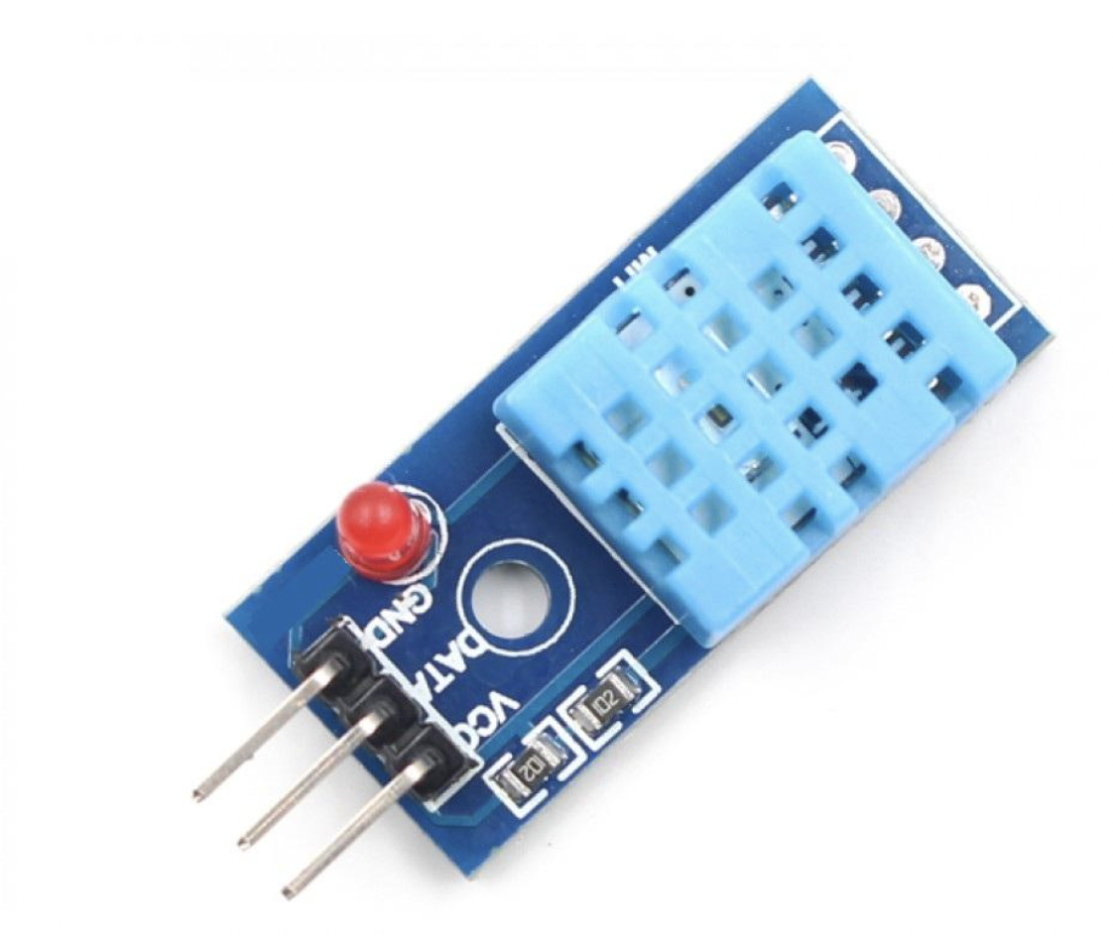

1. Gyroscope(GY521):

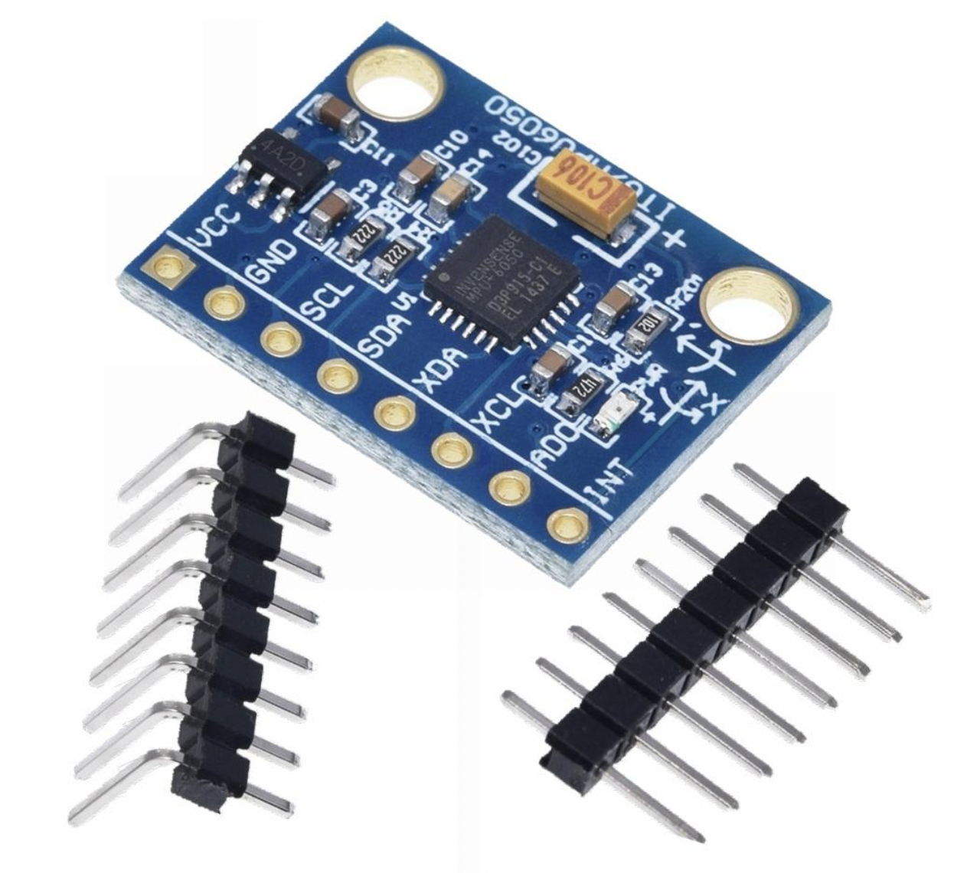

1. IR Sensor:

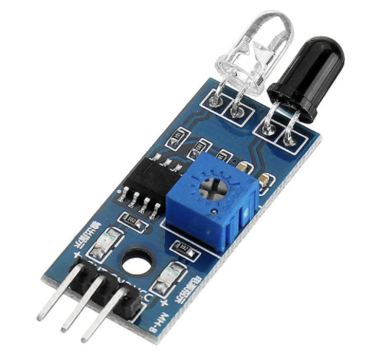

1. PIR Sensor:

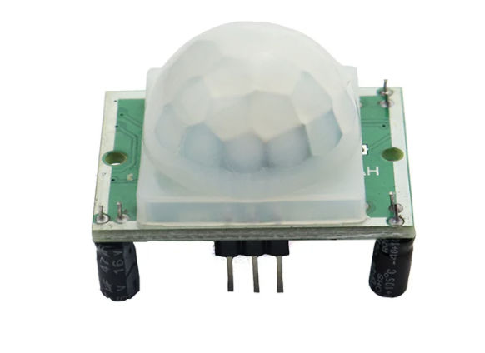

1. Ultrasonic Sensor:

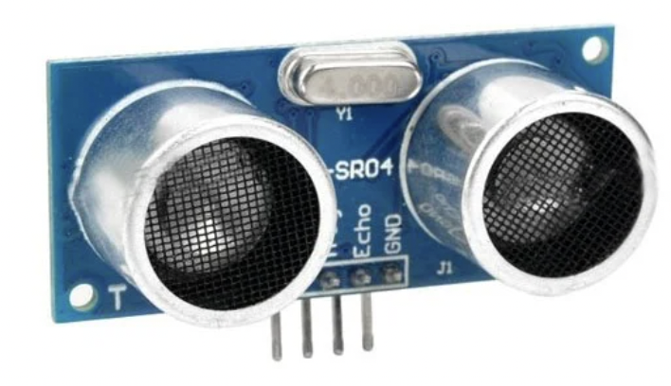

1. Air Quality Sensor(MQ135):

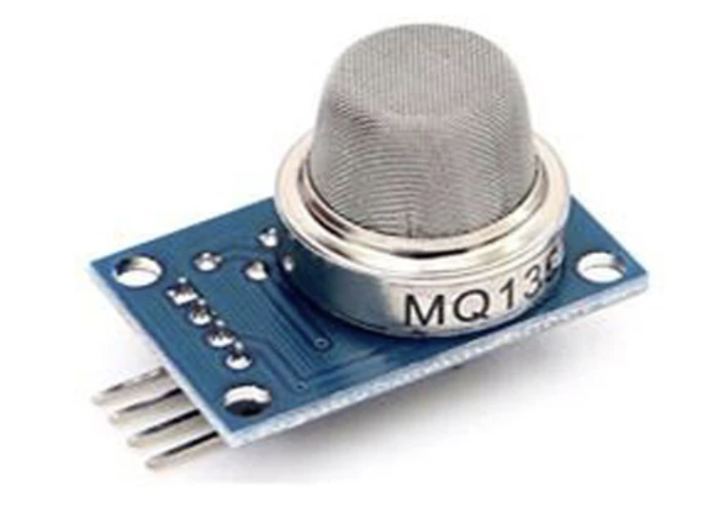

**Software Used:**

1. Arduino IDE



1. ThingSpeak



1. Amazon IoT Core



1. Amazon DynamoDB



**4.5 Circuit Diagram**We have used the following sensors in our model -

Temperature Sensor - For Temperature Monitoring

Accelerometer Sensor, Gyroscope, UltraSonic Sensor - For Fall Detection

Air Quality Gas Sensor - For Measuring the Toxicity in the Air

IR sensor - For Object Detection

PIR sensor - For Motion Detection

Here is the circuit diagram of the sensor network -

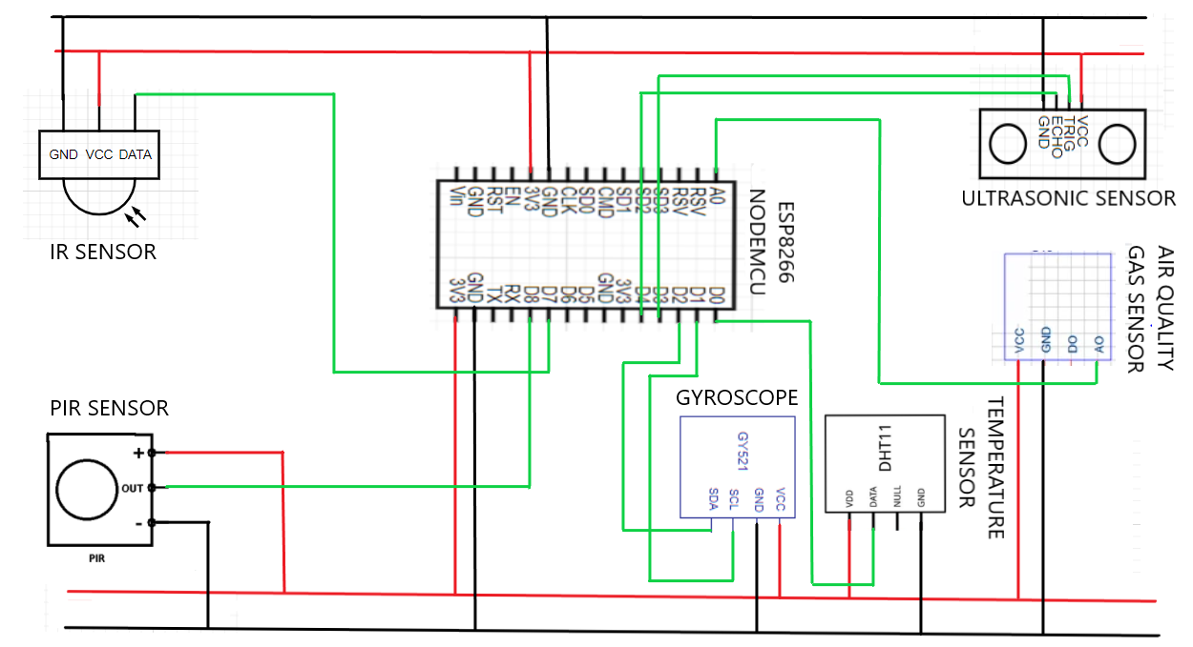

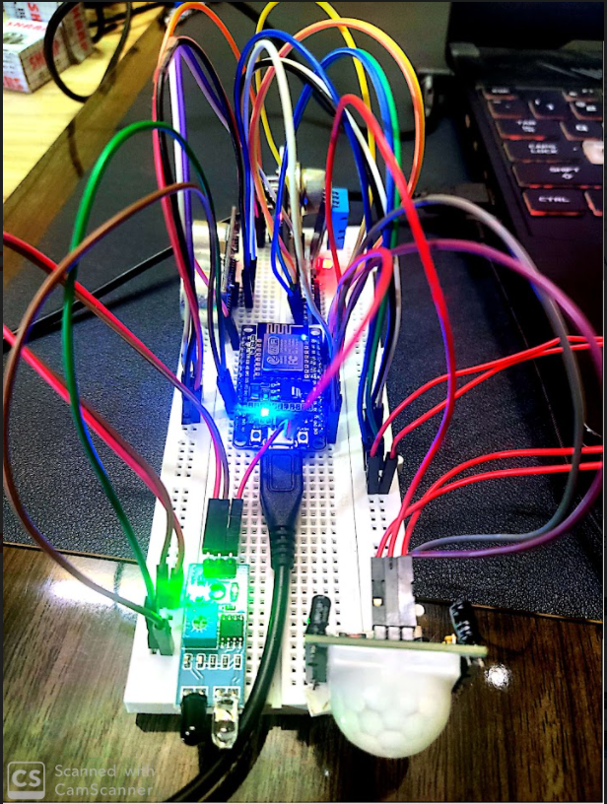

**5.Implementation**

1. **Visualization using ThingSpeak**
   1. Creating a new Channel; giving appropriate name and adding the required fields
   2. After creating a channel, it is hosted as a private channel displaying the graphs for all the fields w.r.t. Date and time.Add appropriate widgets.
   3. Edit the titles and axes w.r.t. fields displayed in the graphs.
   4. In API keys we can see the read and write API keys of the channel. Add the write API key to the .ino file.
   5. Make the channel public in the channel sharing settings
   6. Next, we need the channel to create a new rule to trigger email whenever the data goes above or below the threshold. Under matlab analysis, select read data to trigger email and then create analysis.
   7. In the next page, edit the relevant fields in the code then save and run the code to check for errors. The email will be triggered accordingly whenever the threshold value(s) are reached.



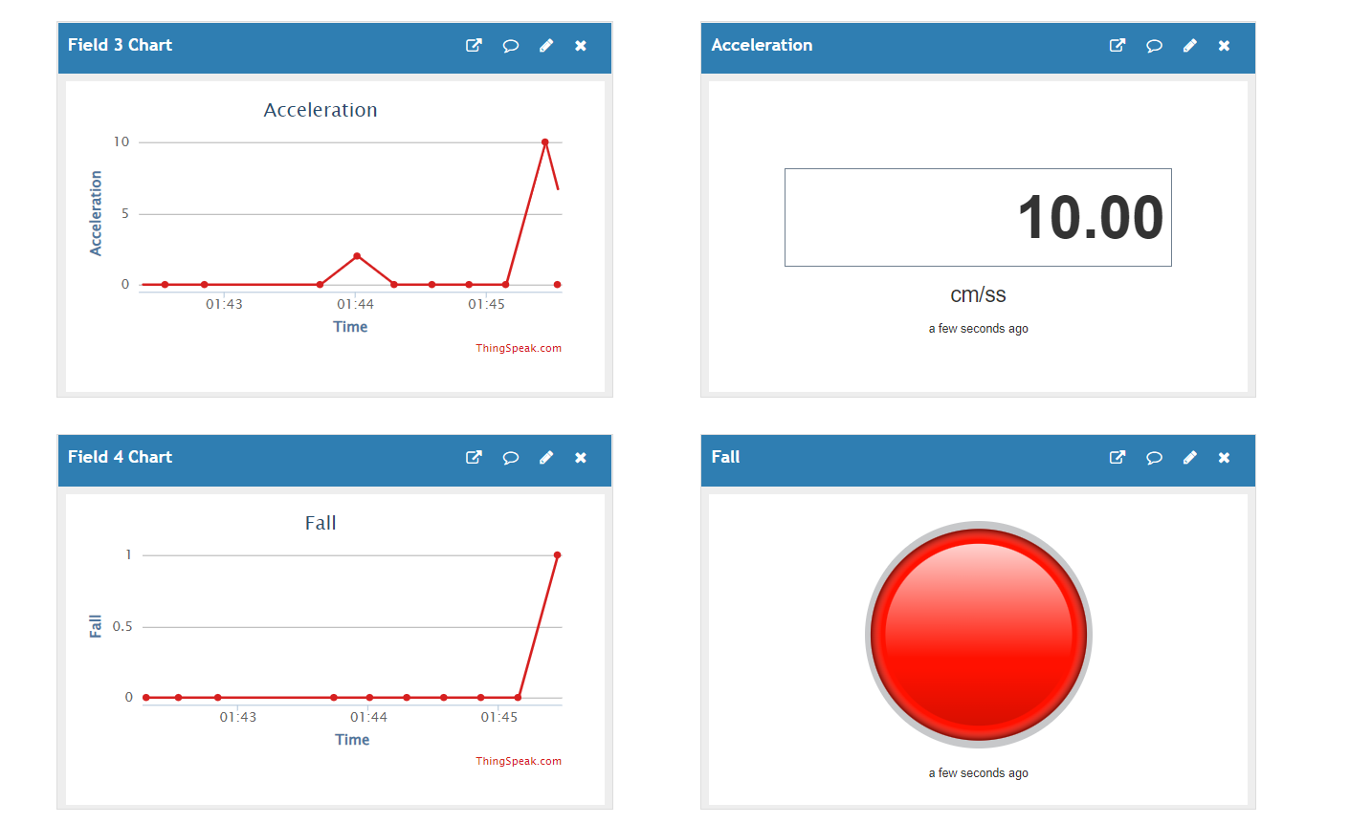

1. **Initialization of DynamoDB table with a connection with MQTT client**

The AWS IOT CORE platform is used to create a thing named ESP8266 with the required details. The certificates and keys were downloaded accordingly.

We then created a policy named ESP8266 and connected it with the rightful certificate.

Next, the MQTT connection is set up named outTopic.

A rule is created on the IOT platform named ESP8266, and the required query statements are accordingly.   
Next a new table is created in DynamoDB named WASN Group 25 for which the partition key for Sl. No. with auto scaling options.

We then connected the DynamoDB table to the rule and defined the functions in the code accordingly.

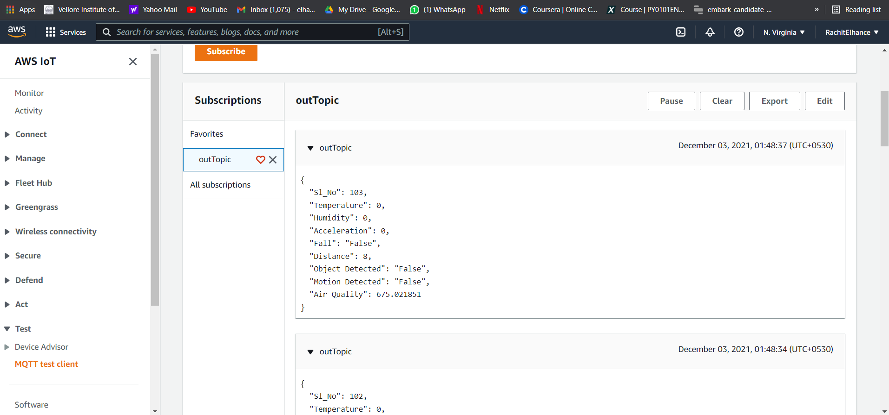



1. **Implementation of User Interface**
   1. We are rendering the HTML code for the user interface from the source code itself by using the library ESP8266WebServer.h.
   2. We use the function SendHTML to append the HTML code with the parameters and send it to the server for the user to see.
   3. An empty string is defined in the function, where the entire HTML code is appended with the CSS properties and SVGs and the received physiological data.
   4. This entire string is then returned and thus the web page for the end user is shown on the server.

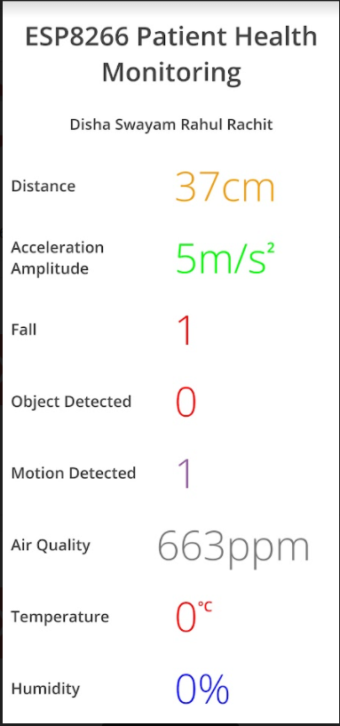

**6. Results and Discussions**

The Serial Monitor prints the data according to the specified formats.

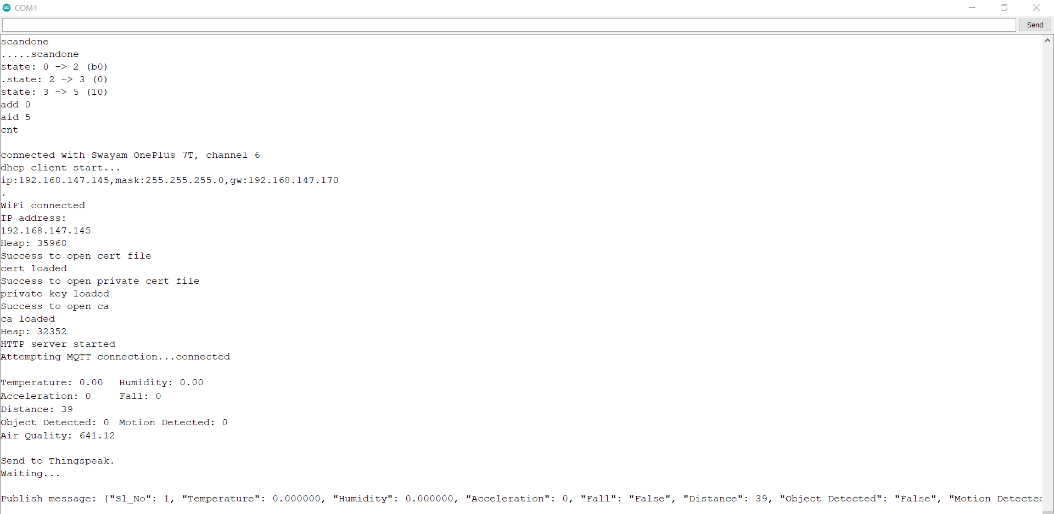

The object sent by the microcontroller is received at AWS IoT through the MQTT client.

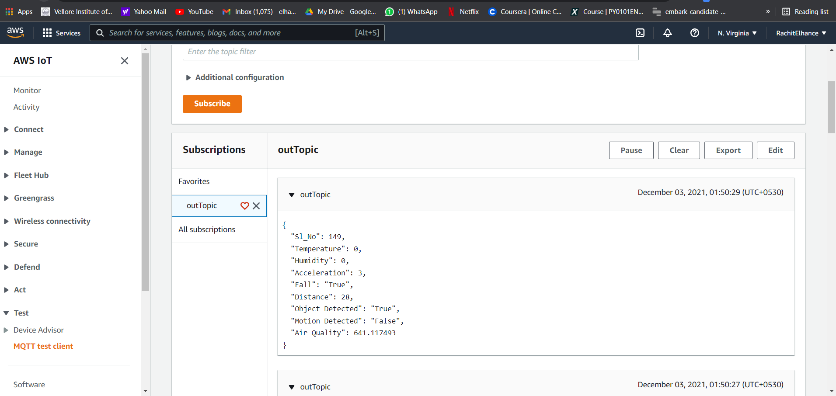

The object is sent to DynamoDB and stored in the cloud.

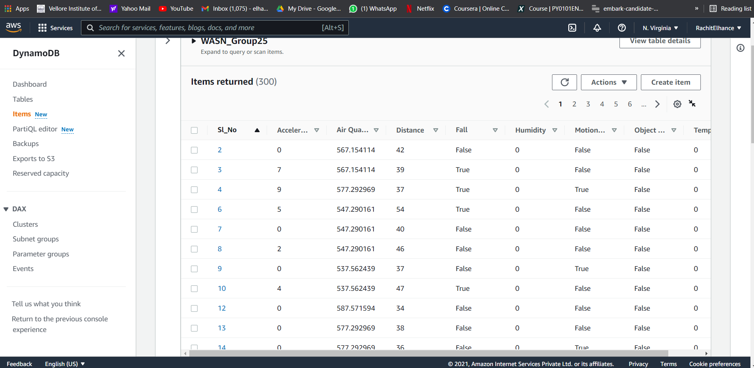

The Scan function can be used to scan and fetch data based on the wish of the user. For example, here the data entries with the parameter value of “Motion Detected” as “True” are scanned and displayed.



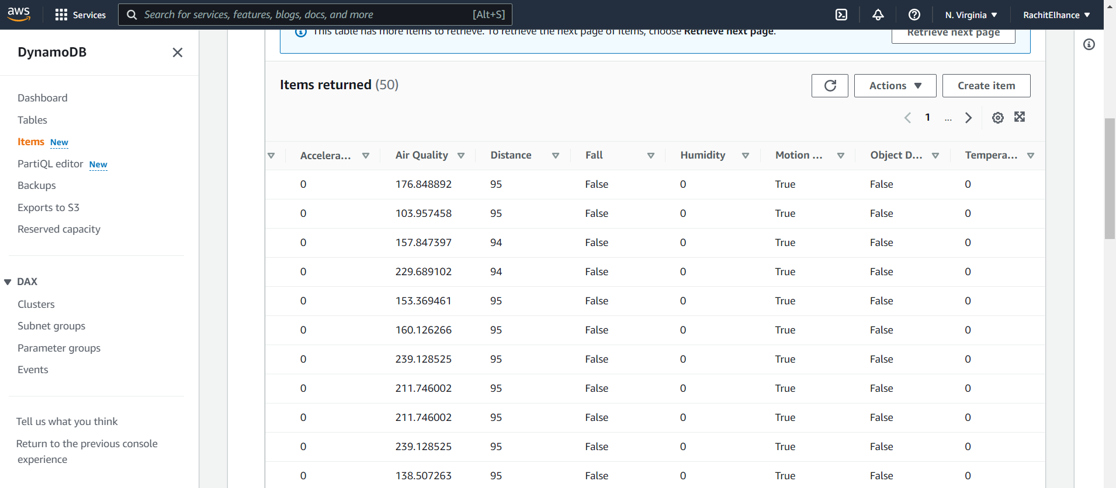

The alert is sent as soon as the incoming data crosses the input parameters. For example, here as soon as the value of the parameter “fall” becomes “True”, an alert is sent to the user.



The statistical data is displayed in the ThingSpeak platform in the form of graphs and buttons with the help of widgets.

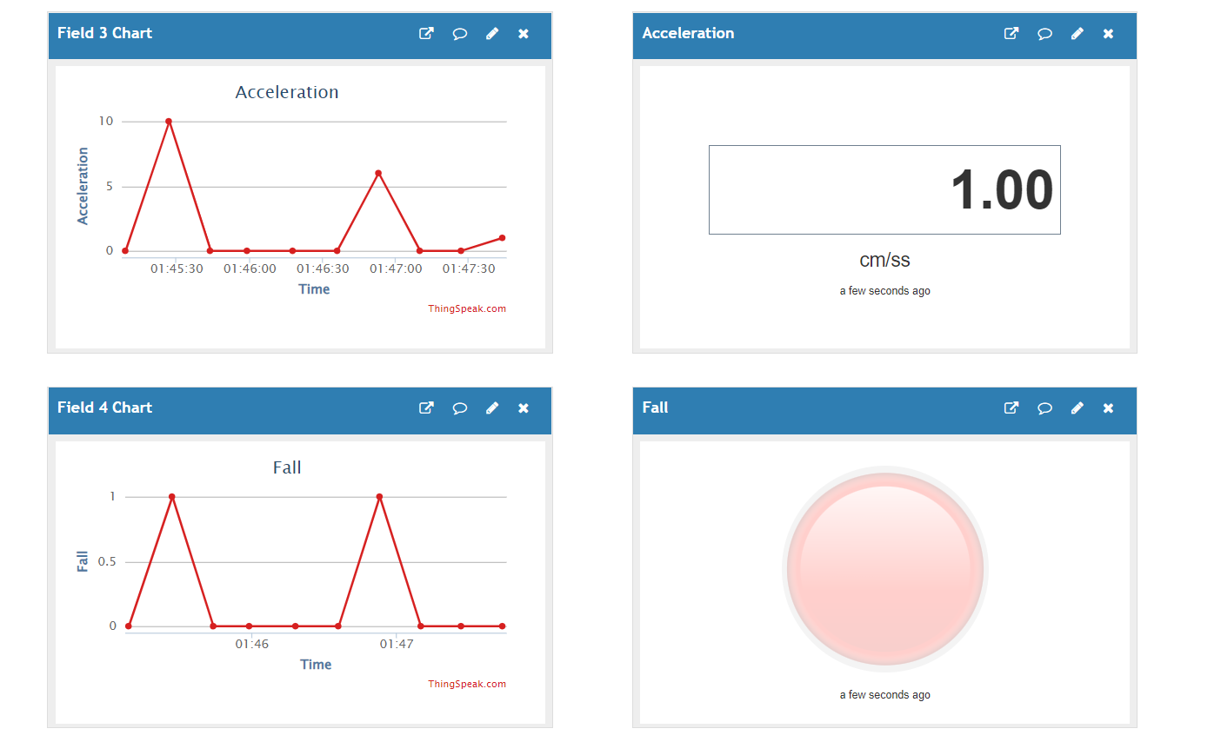

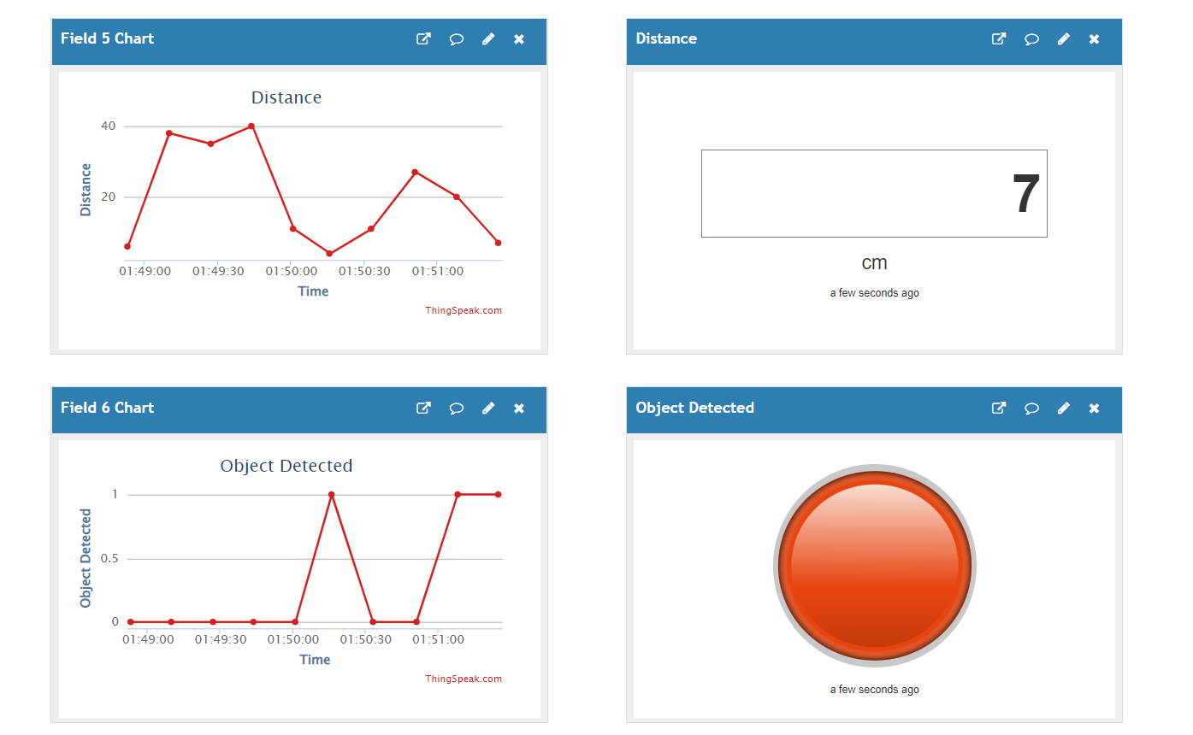

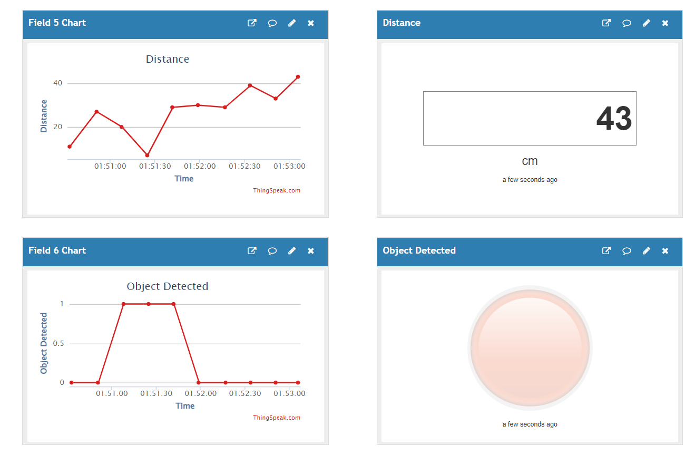

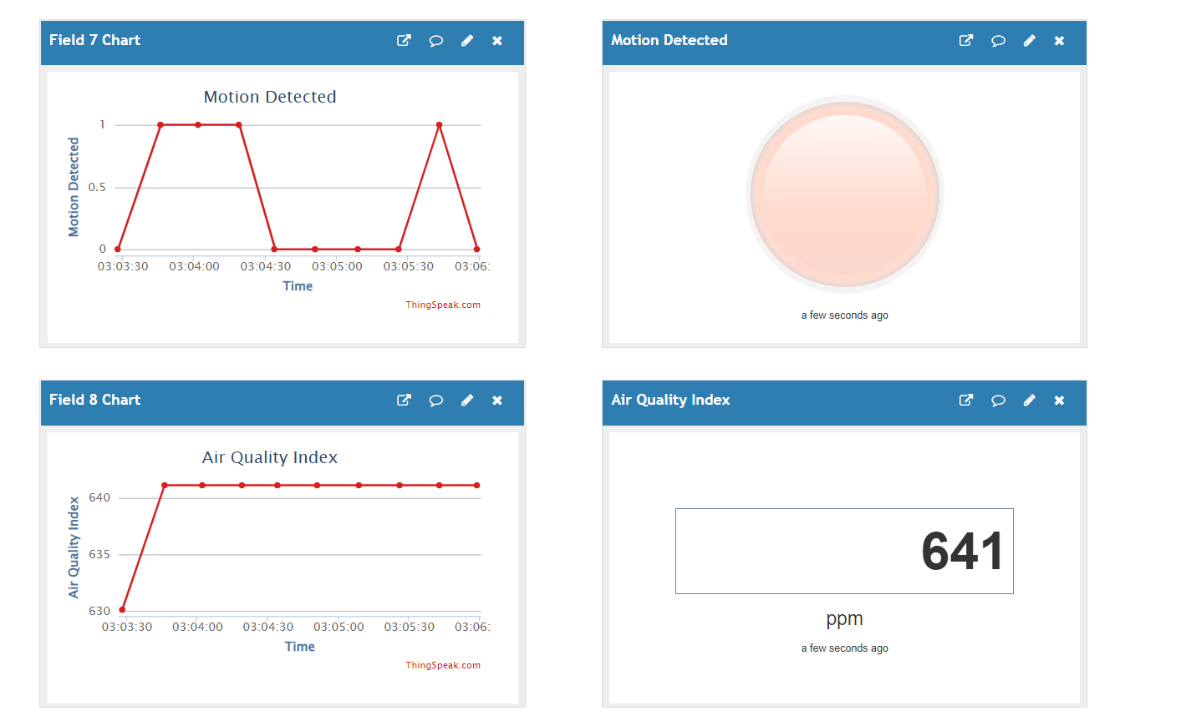

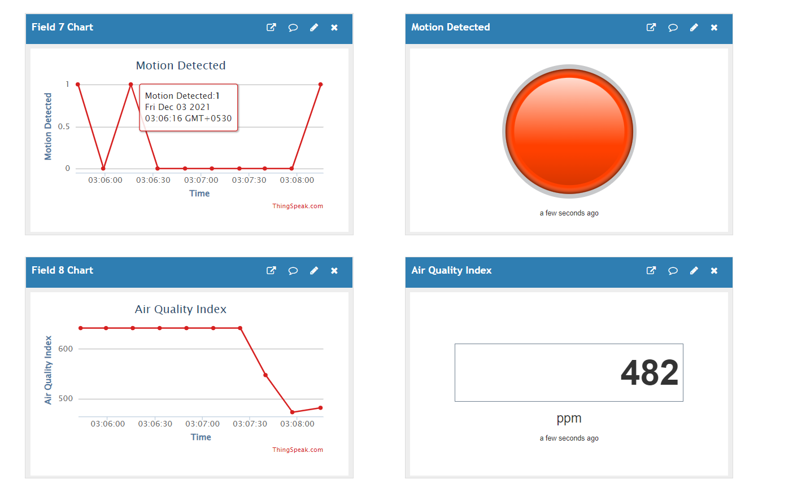

All the values are displayed in the user interface as well in real time.



**7. Conclusion**

The project focused on retrieving physiological data from the wearable sensors worn by the patients and storing it in the database as well as displaying it at all times to the health monitoring department to avoid any casualties. The network of wearable sensors was created with the help of jumper wires and a breadboard. The microcontroller ESP8266, acting as the gateway successfully transmitted the data to the cloud with the help of the AWS IoT platform. The data was fetched from the microcontroller and was sent to the User Interface for the healthcare monitoring department to see and keep a check. The system works properly and efficiently. The data is transmitted in real time and is recorded in a timely manner. The statistical graphs are also displayed accordingly. The alerts are also sent as soon as any of the incoming parameters cross the threshold values. application. The purpose of obtaining complex data values like angle and tilt and then the further system can be used for the gym and fitness industries for posture. Right now, the proposed system has a limited battery source which can be improved as well to accomodate more sensors.

**8. Future Work**

The system of wearable sensors can be improved by adding more efficient sensors for providing more accurate and detailed results. The multiple application sensors would be very beneficial as that would reduce the cost and number of sensors used in the system. Many creative low cost sensors exist but are not used that often. With a good amount of research in the sensor domain, low cost sensors can be introduced to the system making it even more affordable for the hospitals and the end users.The network of sensors can be made more compatible and comfortable for the patients.

The functions can be used to generate more physiological parameter details based on the incoming data using mathematical formulas.

Using Natural Language Processing and Machine learning, the sensor data can be used to predict route patterns and help can be provided more efficiently in case of emergency.

With the help of Machine Learning, datasets from Kaggle or UCL can be used for disease prediction as the function will be working for a finite number of diseases. This increases the flexibility and accuracy of the disease prediction function of our system. New datasets can be generated using our algorithm for further prediction of diseases which did not exist in the detection applications of the real world.

Human requirements for comfort, durability, and often aesthetics are always changing, so technological capabilities in terms of accuracy, performance, and modalities could be explored and worked on accordingly. As Big Data and IoT wearables become increasingly prevalent, they are likely to enable new medical tools and biomarkers for the elderly, enabling home care and pharmaceutical treatment by speeding up and optimizing clinical trials.

**9. References:**

[1] S. Zia, A. N. Khan, K. S. Zaidi, and S. E. Ali, “Detection of Generalized Tonic Clonic Seizures and Falls in Unconstrained Environment Using Smartphone Accelerometer,” IEEE Access, vol. 9, pp. 39432–39443, 2021, doi: 10.1109/ACCESS.2021.3063765.

[2] T. G. Stavropoulos, A. Papastergiou, L. Mpaltadoros, S. Nikolopoulos, and I. Kompatsiaris, “Iot wearable sensors and devices in elderly care: A literature review,” Sensors (Switzerland), vol. 20, no. 10, 2020, doi: 10.3390/s20102826.

[3] S. Shokri, S. Ward, P.-A. M. Anton, P. Siffredi, and G. Papetti, “Recent Advances in Wearable Sensors with Application in Rehabilitation Motion Analysis,” pp. 1–9, 2020, [Online]. Available: http://arxiv.org/abs/2009.06062.

[4] R. Lin et al., “Wireless battery-free body sensor networks using near-field-enabled clothing,” Nat. Commun., vol. 11, no. 1, pp. 1–10, 2020, doi: 10.1038/s41467-020-14311-2.

[5] C. A. Chan, P. Hao, A. F. Gygax, and A. Nirmalathas, “Wireless charging of smartwear for health and safety monitoring system,” 2020 IEEE PELS Work. Emerg. Technol. Wirel. Power Transf. WoW 2020, pp. 223–227, 2020, doi: 10.1109/WoW47795.2020.9291285.

[6] S. Klavestad, G. Assres, S. Fagernes, and T.-M. Grønli, “Monitoring Activities of Daily Living Using UWB Radar Technology: A Contactless Approach,” IoT, vol. 1, no. 2, pp. 320–336, 2020, doi: 10.3390/iot1020019.

[7] S. Mohsen, A. Zekry, M. Abouelatta, and K. Youssef, “A self-powered wearable sensor node for iot healthcare applications,” Proc. 8th Int. Japan-Africa Conf. Electron. Commun. Comput. JAC-ECC 2020, pp. 70–73, 2020, doi: 10.1109/JAC-ECC51597.2020.9355925.

[8] H. Y. Yatbaz, S. Eraslan, Y. Yesilada, and E. Ever, “Activity recognition using binary sensors for elderly people living alone: Scanpath trend analysis approach,” IEEE Sens. J., vol. 19, no. 17, pp. 7575–7582, 2019, doi: 10.1109/JSEN.2019.2915026.

[9] K. Takahashi, K. Kitamura, Y. Nishida, and H. Mizoguchi, “Battery-less shoe-type wearable location sensor system for monitoring people with dementia,” Proc. Int. Conf. Sens. Technol. ICST, vol. 2019-December, 2019, doi: 10.1109/ICST46873.2019.9047673.

[10] A. Noda, “Demonstration of Wireless Access to Batteryless and Antennaless Sensors Distributed on Clothes,” 2019 16th IEEE Annu. Consum. Commun. Netw. Conf. CCNC 2019, pp. 31–32, 2019, doi: 10.1109/CCNC.2019.8651706.

[11] A. Arshad, K. Riaz, T. Tauqeer, and M. Sajid, “Low Cost, Eco-Friendly, Homemade, Graphite on Paper-based Wearable Temperature Sensor,” 2019 Int. Conf. Robot. Autom. Ind. ICRAI 2019, pp. 2019–2022, 2019, doi: 10.1109/ICRAI47710.2019.8967376.

[12] M. Shiomi, S. Nakata, Y. Fujita, T. Arie, S. Akita, and K. Takei, “Highly Sensitive Charge-Coupled Device-based Flexible pH Sensor for Wearable Health Care Application,” 2019 20th Int. Conf. Solid-State Sensors, Actuators Microsystems Eurosensors XXXIII, TRANSDUCERS 2019 EUROSENSORS XXXIII, no. June, pp. 370–373, 2019, doi: 10.1109/TRANSDUCERS.2019.8808504.

[13] A. W. Setiawan and A. R. Ananda, “Development of Low-cost Wearable Walking Pattern Recognition System using Inertial Sensors,” Proceeding - 2019 Int. Symp. Electron. Smart Devices, ISESD 2019, pp. 2019–2022, 2019, doi: 10.1109/ISESD.2019.8909596.

[14] M. Annabestani, I. Mirzaei, P. Esmaeili-Dokht, and M. Fardmanesh, “Design and fabrication of an ubiquitous, low-cost, and wearable respiratory bio-sensor using ionic soft materials,” 2019 26th Natl. 4th Int. Iran. Conf. Biomed. Eng. ICBME 2019, no. November, pp. 55–59, 2019, doi: 10.1109/ICBME49163.2019.9030397.

[15] S. Milici, A. Lazaro, R. Villarino, D. Girbau, and M. Magnarosa, “Wireless Wearable Magnetometer-Based Sensor for Sleep Quality Monitoring,” IEEE Sens. J., vol. 18, no. 5, pp. 2145–2152, 2018, doi: 10.1109/JSEN.2018.2791400.

[16] F. Wu, C. Rudiger, J. M. Redoute, and M. R. Yuce, “WE-Safe: A wearable IoT sensor node for safety applications via LoRa,” IEEE World Forum Internet Things, WF-IoT 2018 - Proc., vol. 2018-January, pp. 144–148, 2018, doi: 10.1109/WF-IoT.2018.8355234.

[17] Z. Lou, L. Wang, and G. Shen, “Recent Advances in Smart Wearable Sensing Systems,” Adv. Mater. Technol., vol. 3, no. 12, 2018, doi: 10.1002/admt.201800444.

[18] R. Jansi, R. Amutha, D. Priyadharshini, L. Saranya, and B. Varshini, “Medical activity monitoring for elderly people using wearable wrist device,” IEEE Int. Conf. Power, Control. Signals Instrum. Eng. ICPCSI 2017, pp. 2578–2582, 2018, doi: 10.1109/ICPCSI.2017.8392183.

[19] C. Wang, S. Chen, Y. Yang, F. Hu, F. Liu, and J. Wu, “Literature review on wireless sensing-Wi-Fi signal-based recognition of human activities,” Tsinghua Sci. Technol., vol. 23, no. 2, pp. 203–222, 2018, doi: 10.23919/TST.2018.8329114.

[20] S. Balguvhar, “Energy Harvesting using d 33 Mode by Insole Embedded Low Cost Piezo- Sensors,” pp. 972–975, 2018.

[21] M. Cornacchia, K. Ozcan, Y. Zheng, and S. Velipasalar, “A Survey on Activity Detection and Classification Using Wearable Sensors,” vol. 17, no. 2, pp. 386–403, 2017.

[22] M. A. Karimi and A. Shamim, “A wearable 3D motion sensing system integrated with a Bluetooth smart phone application,” pp. 17–19, 2017.

[23] M. M. Rodgers, V. M. Pai, and R. S. Conroy, “Recent advances in wearable sensors for health monitoring,” IEEE Sens. J., vol. 15, no. 6, pp. 3119–3126, 2015, doi: 10.1109/JSEN.2014.2357257.

[24] X. Yuan, S. Yu, Q. Dan, G. Wang, and S. Liu, “Fall detection analysis with wearable MEMS-based sensors,” 16th Int. Conf. Electron. Packag. Technol. ICEPT 2015, pp. 1184–1187, 2015, doi: 10.1109/ICEPT.2015.7236791.

[25] L. González-Villanueva, S. Cagnoni, and L. Ascari, “Design of a wearable sensing system for human motion monitoring in physical rehabilitation,” Sensors (Switzerland), vol. 13, no. 6, pp. 7735–7755, 2013, doi: 10.3390/s130607735.

[26] K. D. Nguyen, I. M. Chen, Z. Luo, S. H. Yeo, and H. B. L. Duh, “A wearable sensing system for tracking and monitoring of functional arm movement,” IEEE/ASME Trans. Mechatronics, vol. 16, no. 2, pp. 213–220, 2011, doi: 10.1109/TMECH.2009.2039222.

[27] C. Sugimoto and R. Kohno, “Development of wireless sensing system monitoring physiological information for healthcare in daily life,” Proc. Int. Conf. Sens. Technol. ICST, pp. 488–493, 2011, doi: 10.1109/ICSensT.2011.6137028.

[28] L. Atallah, B. Lo, G. Z. Yang, and F. Siegemund, “Wirelessly accessible sensor populations (WASP) for elderly care monitoring,” Proc. 2nd Int. Conf. Pervasive Comput. Technol. Healthc. 2008, PervasiveHealth, pp. 2–7, 2008, doi: 10.1109/PCTHEALTH.2008.4571011.

[29] K. K. and S. T. H. Mizuno, H. Nagai, K. Sasaki, H. Hosaka, C. Sugimoto, “WEARABLE SENSOR SYSTEM FOR HUMAN BEHAVIOR RECOGNITION,” vol. 3, no. September, pp. 119–122, 2007.

[30] I. Locher, H. Junker, T. Kirstein, and G. Tröster, “Wireless, low-cost interface for body area networks,” Proc. - Int. Symp. Wearable Comput. ISWC, pp. 170–171, 2004, doi: 10.1109/iswc.2004.50.

[31]https://www.un.org/en/development/desa/population/publications/pdf/ageing/WPA2017_Highlights.pdf

[32]https://electronicsinnovation.com/storing-esp8266-data-into-amazon-dynamodb-using-aws-iot-coremqtt-arduino/

[33]https://electronicsinnovation.com/how-to-connect-nodemcu-esp8266-with-aws-iot-core-using-arduino-ide-mqtt/

[34]https://aws.amazon.com/console/

[35]https://stackoverflow.com/

[36]https://thingspeak.com/

**Supporting Documents: Link :**

<https://drive.google.com/drive/folders/1eIlghAwsJaKuwB4KEv-9VLsGDbjtFTr3?usp=sharing>

**9.1 Complete Code**

<https://drive.google.com/drive/folders/1eIlghAwsJaKuwB4KEv-9VLsGDbjtFTr3?usp=sharing>

**9.2 Generated csv file**

<https://drive.google.com/drive/folders/1eIlghAwsJaKuwB4KEv-9VLsGDbjtFTr3?usp=sharing>

**9.3 Video Link:**

<https://drive.google.com/drive/folders/1eIlghAwsJaKuwB4KEv-9VLsGDbjtFTr3?usp=sharing>